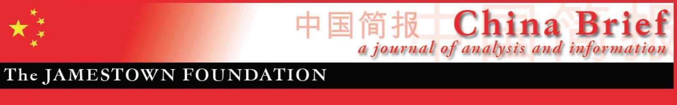
Volume 21 • Issue 20 • October 22, 2021

In This Issue:

As “New Cold War” Fears Rise, China Touts Ties to Southeast Asia
By John S. Van Oudenaren………………………………………….pp. 1-4

Factional Strife Intensifies as Xi Strives to Consolidate Power
By Willy Wo-Lap Lam…………………………………………………pp. 5-8

A Chinese Starlink? PRC Views on Building a Satellite Internet Megaconstellation
By Brian Waidelich……..…………………………………………….pp. 10-15

Russia and China: A Mutually Exaggerated Strategic Partnership?
By Pavel K. Baev …..…………….…………………………...…...pp. 16-20

The US-China Hong Kong Sanctions Face Off
By Anouk Wear……………….………..……………………..........pp. 21-24

***

As “New Cold War” Fears Rise, China Touts Southeast Asia Ties
By John S. Van Oudenaren

China is sharply critical of the US-India-Japan-Australia quadrilateral security dialogue-(the Quad), and the recently launched Australia-US-UK agreement-(AUKUS), charging that these evolving security groupings are destabilizing Asia and the world. Per Beijing, “closed and exclusive cliques” (搞封闭排他的小集团, gao fengbi paitai de xiao jituan) like the Quad stem from the US and its security partners’ lingering “Cold War mentality”(冷战思维, lengzhan siwei) as opposed to China’s self-proclaimed non-hegemonic approach to world affairs that follows the path of “peaceful, open, cooperative and common development.” (和平发展、开放发展、合作发展、共同发展的道路, heping fazhan, kaifang fazhan, hezou fazhan, gongtong fazhan daolu). (Global Times, May 19; FMRPC, March 23; Xinhua, September 22, 2020). In a retort to US President Biden’s September UN General Assembly claim that the US does not seek a new Cold War, the state-affiliated Global Times countered that Biden’s “actual policy” is to “shift culpability for the onset of the new Cold War to China and other parties.” (Global Times, September 22).

To press the case that the US and its security partners are driving a “New Cold War” in Asia, China plays on Southeast Asian states’ general anxieties over the increasingly competitive security environment in the region. Beijing has also promoted the notion that the Quad and AUKUS will supplant, rather than compliment, Association of Southeast Asian Nations (ASEAN) centrality in regional affairs. For example, in a September 29 call with the Foreign Ministers of Brunei and Malaysia, Chinese Foreign Minister Wang Yi claimed that AUKUS would harm the Asia-Pacific region in five ways. Wang asserted that the defense pact: 1) heightens the risk of nuclear proliferation; 2) contributes to a regional arms race; 3) undermines regional peace and prosperity that is central to the ASEAN way; 4) violates the South Pacific Nuclear Free Zone Treaty that Canberra has signed, and runs counter to the spirit of Southeast Asia Nuclear Weapon-Free Zone treaty; and 5) revives a Cold War mentality and ushers in an era of “geopolitical zero-sum games” (People’s Daily, September 29).

In order to draw a contrast to the US, the Quad and AUKUS, China highlights its contributions to regional prosperity through its immense trade and investment linkages with Southeast Asia, while glossing over its own destabilizing security actions in the region, particularly in the South China Sea. Chinese leaders routinely underscore that all ten ASEAN states’ inclusion in the Beijing initiated Regional Comprehensive Economic Partnership (RCEP) free trade agreement, which China asserts will accelerate Southeast Asia’s development and prosperity (China Daily, September 13). At the same time, China amplifies Southeast Asian voices that express apprehension over the Quad and AUKUS while dampening those voices raising concerns about China’s assertiveness in the region.

Selective Amplification of AUKUS, QUAD Skepticism

The People’s Daily recently published an editorial entitled “Australia-US-UK submarine deal undermines global stability” under the penname “Warning Bell” (钟声, Zhong Sheng), which is used to denote authoritative leader-level perspectives on key international issues. The piece raises the same issues cited by Wang Yi, but also highlights Malaysia’s concerns that the provision of nuclear technology to Australia will “intensify momentum towards an arms race” (People’s Daily, October 19). This editorial echoes extensive Chinese state media articles including quotes with serving and retired Southeast Asian elites expressing their unease over AUKUS. For example, in an interview with the Global Times, retired Singaporean Diplomat and Academic Kishore Mahbubani states that there are “fundamental concerns” over whether AUKUS “violates the nonproliferation regime.” (Global Times, October 12). In September, Xinhua quoted Malaysia’s Prime Minister Ismail Sabri Yaakob’s warning that AUKUS could stoke tensions in Asia, as well as former Prime Minister Mahathir Mohamad’s comment that the move was an “escalated threat” to the region (Xinhua, September 24). These accounts neglect to mention Malaysia’s unease with China’s assertiveness in the region, including that Kuala Lumpur has lodged complaints with the UN Convention on Law of the Sea contesting the legal justification for China’s sweeping South China Sea (SCS) claims (Nikkei, July 30, 2020).

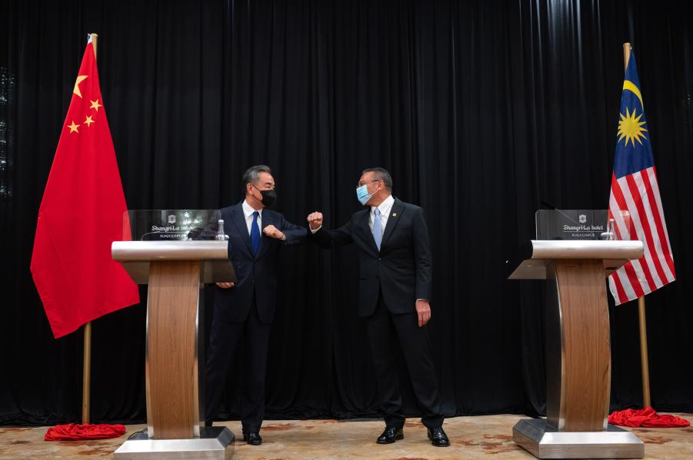

(Chinese Foreign Minister Wang Yi and Malaysian Foreign Minister Hishammuddin Hussein bump elbows at a press conference in Kuala Lumpur, Malaysia in October 2020, Source: Xinhua)

An ‘Asian-Style Approach’ to International Relations

China has held up its relations with ASEAN and its ten member states as a positive model for international politics and an alternative to “Cold War” style security groupings like the Quad and AUKUS, which Beijing perceives as a challenge to its bid for regional primacy. Foreign Minster Wang Yi, in remarks to commemorate the 30th anniversary of the establishment of China-ASEAN relations, stated that China and ASEAN have “embarked on a path of unity and win-win cooperation” and “have carried forward an Asian-style approach to relations and continued good-neighborly friendship.” (FMPRC, October 8). To drive home this point, Wang emphasized China and ASEAN’s deep economic ties, highlighting large-scale Chinese investment in regional infrastructure through the Belt and Road Initiative, and enormous trade flows that RCEP will only further.

Wang’s praise for China-ASEAN ties should be read as more than mere bromides. In a departure from China’s previous neo-Westphalian approach to international diplomacy, which was based on rigid deference to state sovereignty, China under Xi has adopted a Sino-centric approach to diplomacy predicated on asserting its “international discourse power” (国际话语权, discourse power, guoji huayu quan) and “telling the China story well” (讲好中国故事) (Xinhua, December 29, 2016) Although concepts such as discourse power predate Xi’s leadership tenure, they have assumed added importance under his leadership, and have been broadly encapsulated under the rubric of “Xi Jinping Thought on Diplomacy” (习近平外交思想). Xi’s approach to diplomacy is characterized more by Chinese exceptionalism and idealism than the traditional realist approach to foreign affairs followed by his predecessors (China Media Project, August 8). In contrast to what it portrays as the US’s Cold War, zero-sum approach to diplomacy, China has sought to advance alternative concepts for regional and global politics, claiming its foreign relations are predicated on “win-win cooperation” (合作共赢, hezuo gongying) and wide consultation, joint contribution, and shared benefits (共商、共建、共享 (gongshang, gongjian, gongxiang) (NBR, January, 2020; Xinhua, November 6, 2020).

Rhetoric versus Reality

Although China is quick to claim it is a new type of great power that eschews power politics, its actions in the region often contradict that premise. Along with its long-running militarization of the Paracel and Spratly Islands in the South China Sea, China’s recent lack of transparency regarding its potential military activity in Cambodia violates Beijing’s commitments under its 2003 Treaty of Amity and Cooperation with ASEAN, wherein China and ASEAN agreed to a “strategic partnership for peace and prosperity” that “is non-aligned, non-military, and non-exclusive, and does not prevent the participants from developing their all-directional ties of friendship and cooperation with others.” (CSIS, October 12; People’s Daily, October 9, 2003). In response to US concerns that China’s recent construction activities at Ream Naval Base in Southern Cambodia are intended to facilitate a Chinese military presence in the country, Beijing stated its relationship with Cambodia had made “made positive contributions to regional peace and stability” (AP News, June 3). Nevertheless, China’s growing security footprint in the region demonstrates that Beijing bears much of the culpability for the region’s increasingly fraught security environment. Likewise, Beijing lashing out against “exclusive cliques” like the QUAD or AUKUS and its promotion of non-alignment is contradicted by China’s own efforts to build its own web of security partnerships to counterbalance the networked security architecture that the US and its allies and partners are building in the region. The underlying wariness of ASEAN’s leading states, e.g. Indonesia, Malaysia and Singapore, toward China’s motives, along with Beijing’s clientelist relationship with Cambodia and other weak states in the region, only serves to underscore this reality.

John S. Van Oudenaren is Editor-in-Chief of China Brief. For any comments, queries, or submissions, please reach out to him at: cbeditor@jamestown.org.

Factional Strife Intensifies as Xi Strives to Consolidate Power
By Willy Wo-Lap Lam

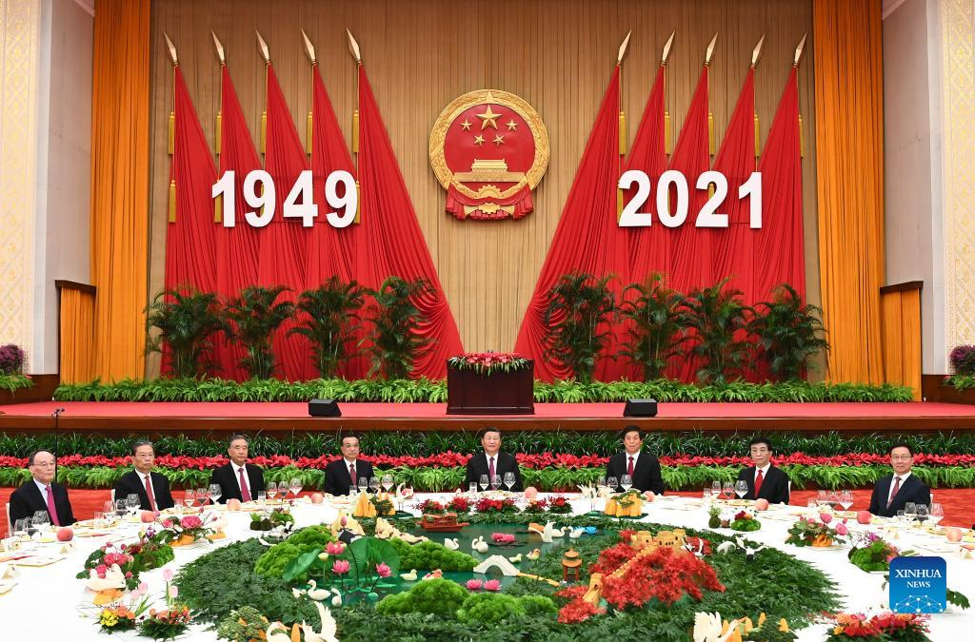

(Top party and state leaders attend a reception to celebrate the 72nd anniversary of the PRC’s founding at the Great Hall of the People in Beijing, Sept. 30, 2021. Pictured (from left to right): Wang Qishan, Zhao Leji, Wang Yang, Li Keqiang, Xi Jinping, Li Zhanshu, Wang Huning and Han Zheng. (Source: Xinhua)

Introduction

More evidence has emerged of a ferocious power struggle between China’s supreme leader, President Xi Jinping and powerful factions and personages including former Vice-President Zeng Qinghong and current Vice President Wang Qishan. Not-so-subtle instances of in-fighting among these influential figures and their cliques have emerged in the wake of the revelation last month by the semi-official NetEase and Sohu websites that several senior officials in the political-legal apparatus (政法系统, zhengfa xitong), which includes the police, the secret police and the courts, had plotted “sinister and treacherous” (不轨, bugui) actions against a top party leader, generally thought to be Xi (See China Brief, September 23). (These articles have since been deleted from the Internet).

The factional back-stabbing has worsened even as the economy battles strong headwinds. In the wake of the near-bankruptcy of Evergrande Group, one of the largest real-estate conglomerates in the world, more property and financial firms are reportedly unable to service their multi-billion yuan debt burdens. The total national debt reached 335 percent of GDP at the end of last year, while external debt alone has breached the $2.68 trillion mark (SAFE.gov.cn, September 30; Hong Kong Economic Times, November 19, 2020). Apart from the infrastructure sector, local government investment vehicles are estimated to have incurred loans of 53 trillion yuan ($8.23 trillion) through the end of 2020, up from 16 trillion yuan ($2.5 trillion) in 2013. Moreover, China faces an energy shortage that is partially caused by depleted coal supplies. On the foreign-policy front, trade talks with the US have yet to be reopened, and the Biden administration is persevering with efforts to build a coalition of like-minded nations to counter China’s increasingly aggressive behavior in areas including in the Taiwan Straits, the East China Sea and South China Sea (Asia.nikkei.com, October 4; Times of India, September 27).

Trouble with Wang Qishan?

Xi, who has not traveled abroad for more than 630 days, seems busy handling challenges from different quarters as he lays the groundwork for the 20th Party Congress next year, whose theme is likely to be the confirmation of the strongman as the party’s “core for life” (终身核心, zhongshen hexin). Earlier this month, well-regarded journalist Hu Shuli(胡舒立), the founder and editor of the liberal online magazine, Caixin.com, posted the following message about a certain “pighead” in the culinary section of the news outlet’s we-chat account (United Daily News, October 7). “If a pighead is well cooked, it can of course be delicious,” the brief note said. “Yet if a pighead is not respected, this has to do with people’s way of thinking. Ordinary people won’t think of forming a strategic relationship on the dining table with a pighead that bears a bad name.” “Pighead” is one of the nicknames used for Xi. And although this posting is supposed to be associated with culinary matters, the mention of “strategic relationship” seems a sleight-of-hand critique of Xi’s stubborn conservatism and his failure to establish solid ties with Western countries (Tang Jingyuan Youtube Channel, October 8; United Daily News, October 7).

Over the past 20 years, Hu has written and edited many controversial stories exposing the wrongdoings of powerful officials and princelings (offspring of party elders). Her courageousness is attributed to the “protection” provided by Wang Qishan, who was a member of the Politburo Standing Committee (PBSC) and Secretary of the Central Commission for Disciple Inspection (CCDI) – the party’s highest anti-graft body – during Xi’s first term (2012-2017). Wang is considered by many to be one of Xi’s closest allies, he was given the highly respected title of Vice-President in 2013, and that he was once considered Xi’s main advisor on relations with the U.S However, Wang has gradually fallen out of favor with the supreme leader since leaving the Politburo in 2017. (Asia.nikkei.com, October 8, 2020; Hong Kong Free Press, April 9, 2020).

Late last year, Ren Zhiqiang(任志强) a princeling and real-estate mogul in addition to a widely followed Internet commentator, was sentenced to eighteen years in jail for alleged corruption and embezzlement. Yet the severe punishment meted out to Ren, who is known to be a close friend of Wang Qishan, is thought to have been caused by the former’s internet posting about a certain “disrobed clown who insists on being the emperor” (Radio French International, September 25, 2020; Central News Agency, September 24, 2020). Xi is often referred by his critics as “the emperor who wears no clothes” and Ren’s dig at Xi caused a big excitement among liberal intellectuals in the country.

Wang is also considered to be a hidden patron of several enterprises, which have been penalized by the authorities for irresponsible management and reckless overseas investment. Foremost among these enterprises is HNA Group, a Hainan-based company, which rose from a regional airline to an international conglomerate in less than 20 years (China Digital Times, February 12, 2018). HNA went bankrupt earlier this year largely due to its inability to repay debts estimated at $77.3 billion. HNA Chairman Chen Feng (陈峰) was arrested in September for alleged economic crimes and anti-party activities. Chen is considered a protégé of Wang, who is a former party secretary of Hainan province (SCMP, September 20; Asia.Nikkei.com, March 16). The confessional-style announcement issued by the HNA board after Chen’s arrest seemed to show that more than illicit business activities were involved. “Ambition and wild desires have led the whole group into a deep gully,” the statement said (Thestandnews.com, September 25; The Paper, September 24).

Yet another close associate of Wang, former CCDI official Dong Hong(董宏), was arrested last April for embezzlement and a “degenerate lifestyle”. A vice-ministerial-level cadre, Dong was Wang’s right-hand man when the latter was party secretary of the CCDI. Dong was head of the team that the CCDI set up in 2013 to investigate malpractices in provincial and government bodies. He was accused of “seriously infringing upon political discipline and political regulation” as well as “being disloyal to the party.” (Asianews.it, April 27; New Beijing Post, April 26). Going against “political discipline and political regulation” are considered code words for not being loyal enough to the party “core,” President Xi.

Pushback from a Key Party Elder

Even more obvious is the power struggle between Xi and former PBSC member and Vice President Zeng Qinghong. Zeng, a princeling and close aide of former president Jiang Zemin, is also a major leader of the so-called Shanghai Faction. Zeng is believed to be the “protection umbrella” behind several multi-billion enterprises. One of these enterprises, Fantasia Holdings (花样年控股集团有限公司, huayang nian konggu jituan youxian gongsi), which is headed by his niece Zeng Baobao (曾宝宝). Fantasia was recently downgraded to “default” status by rating agencies due to failure to pay interests on bonds and promissory notes. As of the middle of this year, Fantasia had current liabilities – those that have to be repaid within a year – of nearly 50 billion yuan ($7.5 billion) (Caixinglobal.com, October 7; SCMP, October 6). Yet, Zeng Baobao seemingly blamed the party’s highest authorities for her company’s downward spiral. She said in a controversial We-chat post that while professional matters should be left to professionals, very often “decisions are made by people whose brain is conditioned by their buttocks.” She added that the future of her company “will be handed over to the person whose buttocks are anchored most securely.” (屁股决定脑袋的决策，交给屁股坐得最定的那个, pigu jueding naodai de juece, jiao gei pigu zuo de zui ding di nage). Zeng’s subtle comments seemed to be targeted at Xi, who has been putting pressure on a host of real estate and technology companies , some of which have been nationalized (United Daily News, October 8; Radio Free Asia, October 7).

Zeng Qinghong’s most serious “offence” may be his association with the late Lai Xiaomin(赖小民), a veteran banker who used to head the state-owned China Huarong Asset Management Company (CHAMC) (中国华融资产管理公司, Zhongguo huarong zichuan guanli gongsi). Lai was arrested late last year and was executed this January. He was accused of having pocketed some 1.79 billion yuan in bribes and of being “disloyal to the party.” Yet the relationship between Zeng and Lai goes back a long way. They hail from neighboring counties in Jiangxi Province, and Zeng played a role in Lai’s meteoric rise in the financial establishment (Radio Free Asia, January 22; Tw.news.yahoo.com, January 6). Zeng Baobao’s Fantasia Group Holdings was also a business partner of CHAMC. In exclusive reports run by NetEase and Sohu.com, Lai is said to be the financier behind “sinister and treacherous” actions planned by senior Jiangsu zhengfa officers including Wang Like (王立科), Luo Wenjin (罗文进) and Yang Ming (严明) to do harm to Xi (News.youth.cn, September 22; Radio Free Asia, September 16).

Xi Purges Former Rival’s Protégés from Police Forces, Judiciary
Xi’s long-standing distrust of the political-legal (zhengfa) apparatus springs from the fact that his arch-enemy, former PBSC member and internal security czar Zhou Yongkang, who was sentenced to lifetime imprisonment in 2015, still has large numbers of followers and underlings in the police, the secret police, and the judicial system. This is the driving force behind Xi’s multi-year purge of the zhengfa system. After arresting three former Vice Ministers of public security – Li Dongsheng (李东生) (2013), Meng Hongwei (孟宏伟) (2018) and Wang Like (王立科) (2020) for economic and disciplinary infractions – the CCDI announced on October 2 that former executive Vice Minister of Public Security Fu Zhenhua (傅振华) was being investigated for similar crimes. Even though Fu played a key role in the investigation of Zhou Yongkang in 2013 and 2014, he is believed to have lost Xi’s trust due to his close association with other Zhou protégés such as Wang Like. Most of the disgraced former senior police cadres have been accused of “forming cliques and factions” within the internal security system (VOAChinese.com, October 8; theinitium.com, October 5; China.caixin.com, October 4;).

A number of the members of the zhengfa system, who have been targeting for discipline by the Central Leading Group on Inspection Work (CLGIW) (中央巡视工作领导小组, Zhongyang xunshi gongzuo lingdao xiaozu), which has periodically sent inspection teams to party and government units, as well as provincial and municipal administrations to asses mid- to senior level cadres’ political rectitude and possible economic crimes. Last year, the CLGIW, which is headed by the PBSC member and Secretary of the CCDI Zhao Leji, dispatched inspectors to several zhengfa units including the Ministry of Public Security, Ministry of State Security, the Justice Department, and the procuratorate and court systems (CCDI website, April 20; MOJ.gov.cn, August 23, 2020). Currently, the CLGIW, which was set up in 2009 but which did not become active until Xi became party head in 2012, is investigating 25 financial units including the People’s Bank of China, major state banking and insurance companies as well as regulatory agencies such as the China Securities Regulatory Commission and the China Banking Regulatory Commissions (Finance.sina.com, September 26; Finance.caixin.com, September 26). As Wang Qishan and Zeng Qinghong have, in both their public and private capacities, been active in the investment and banking sectors, it is possible that more protégés of these alleged political foes of Xi may yet be uncovered.

Conclusion

Xi has in many speeches linked his authority as “party core” to his ability to effectuate “self-purification and self-renewal” of the party. Part of his reputation lies in his ability to bring down a relatively large number of “tigers,” or senior cadres, for economic crimes and disciplinary problems. So far, his rivalry with Zeng Qinghong and Wang Qishan has manifested itself mainly in verbal innuendoes. For example, Xinhua and the People’s Daily have run a series of commentaries saying that the anti-corruption campaign will not tolerate any “Iron Head Princes” (铁头王, Tie tou wang) “The anti-graft movement has no upper limits,” People’s Daily declared last January. “The CCP is not afraid to face problems squarely and to rectify its mistakes… we are good at self-purification and self-renewal” (Xinhua, July 11; People’s Daily, January 15). Pledges about the CCP’s capability to “self-reform and self-purify” were repeatedly made by Xi in major speeches including his address marking the centenary of the CCP’s establishment. “Iron Head Prince,” which was one of the titles Qing Dynasty emperors gave to senior noblemen, is considered a reference to Zeng Qinghong. This is due to the fact that the last Iron Head Prince bore the title of Prince Qing. The 20th Party Congress will, Xi hopes, confirm his ability to retain his status as party General Secretary, State President and Chairman of the party’s Central Military Commission for a decade. In the meantime, internecine bickering within the party could move beyond rhetorical allusions, and bring about the downfall of at least a couple of former Politburo and PBSC members.

Dr. Willy Wo-Lap Lam is a Senior Fellow at The Jamestown Foundation and a regular contributor to China Brief. He is an Adjunct Professor at the Center for China Studies, the History Department, and the Master’s Program in Global Political Economy at the Chinese University of Hong Kong. He is the author of five books on China, including Chinese Politics in the Era of Xi Jinping (2015). His latest book, The Fight for China’s Future, was released by Routledge Publishing in July 2019.

***

A Chinese Starlink? PRC Views on Building a Satellite Internet Megaconstellation

By Brian Waidelich

Introduction

Billions of people around the world depend on the internet each day to make government, commercial, or personal transactions, and millions more users are being added each year. However, high-speed, reliable, and affordable internet services are not yet accessible to everyone. As Zhang Monan, a researcher at the China Center for International Economic Exchanges’ Belt and Road research group, assesses, developing countries’ dearth of internet infrastructure constitutes a “digital divide” separating them from the global high-tech economy (Economic Daily, August 19).

Most of the world’s internet traffic travels through fiber-optic cables, which achieve economies of scale in urban areas but are expensive to lay in less populated regions. Some of the demand for internet services in remote regions and from mobile platforms (such as aircraft and ships) is met by satellites in high-altitude geostationary and medium Earth orbits, but their services are costly and their latency (the time required for a signal to travel between a satellite and Earth) is high.

The advent of broadband internet from satellites in low Earth orbit (LEO) stands to fill the gap in terrestrial communications and overcome weaknesses in existing satellite internet services. In recent years, Western commercial space companies including SpaceX, OneWeb, and Amazon have unveiled plans to deploy tens of thousands of satellites in low-altitude megaconstellations (Deloitte, February 19, 2020). Unlike previous satellite internet services, these new constellations are being constructed at much lower altitudes—and in much greater numbers—to reduce signal latency and enable applications with rapid ping rates, such as online gaming and drone flights. Since 2018, SpaceX has taken the lead in the rollout of its own constellation, Starlink. With reusable Falcon 9 Rockets deploying dozens of Starlink satellites in a single trip, SpaceX has sent nearly 1,800 of the constellation’s satellites into orbit as of September this year (SpaceFlight Now, September 14).

More recently, China has also signaled its intention to deploy LEO satellite internet at scale. On April 26, a meeting was held in Beijing to mark the establishment of China Satellite Network Group Co. Ltd. (中国卫星网络集团有限公司), a vice-ministerial state-owned enterprise (SOE) that will oversee the construction of a satellite internet megaconstellation (Xinhua, April 29; SASAC, April 29). Headquartered in Hebei Province’s Xiong’an New Area, the new SOE will manage the planning and operations of “Guowang” (国网), a network of sub-constellations that may eventually comprise as many as 12,992 satellites in LEO (CCTV, April 29). The megaconstellation will fold in the much smaller, partially deployed Hongyun and Hongyan communications satellite constellations of the state-owned China Aerospace Science and Industry Corporation (CASIC) and China Aerospace Science and Technology Corporation (CASC), respectively. It is unclear what other companies may participate in the construction and launch of Guowang satellites.

While little is yet known about China Satellite Network Group or Guowang, China’s space proponents are optimistic about LEO satellite internet’s potential to drive domestic economic growth and support the Chinese military’s communications infrastructure. At the same time, some Chinese writings express concerns about China’s ability to compete with Western commercial space companies in areas including technological capabilities and access to necessary space resources. This article examines Chinese views about the opportunities and challenges of satellite internet development and concludes with several areas to watch as China moves forward with the megaconstellation’s deployment.
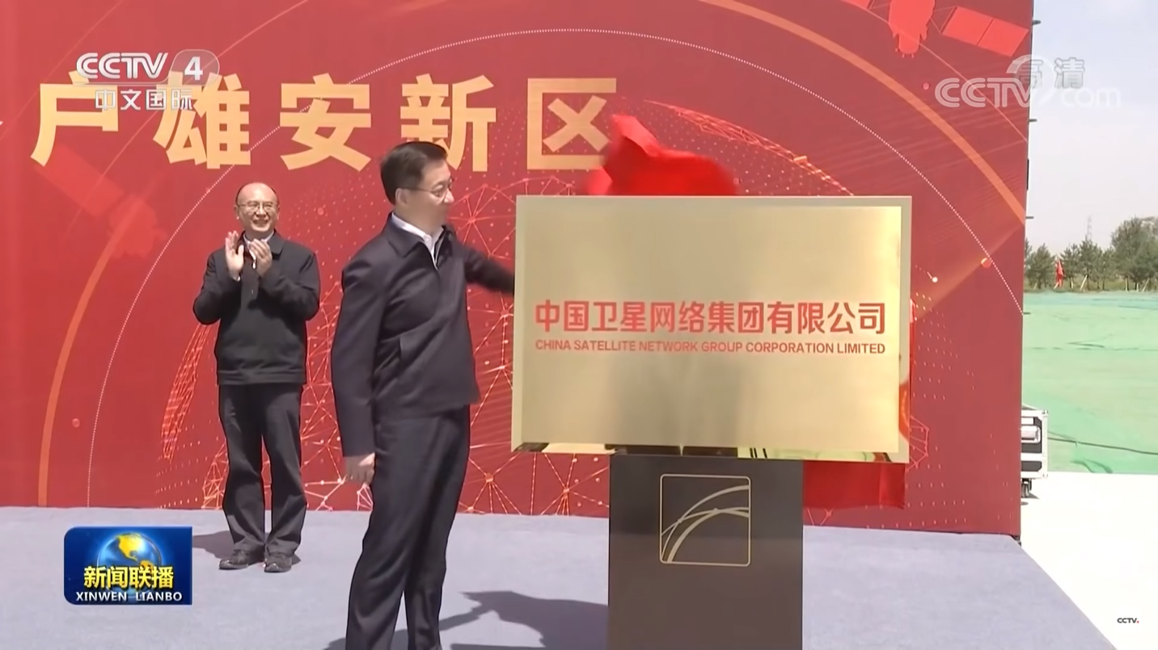

On April 28, 2021, PRC Vice Premier Han Zheng unveiled the plaque of China Satellite Network Group at the newly established SOE’s construction site in Xiong’an New Area. (Source: CCTV)

China’s Expectations for Satellite Internet

Chinese state media and aerospace industry leaders foresee rapid growth in China’s satellite internet market over the next decade. Science & Technology Daily claimed the domestic satellite internet market could reach 100 billion Chinese yuan (about $15.5 billion) in value by 2030, an estimate based on figures from the financial services provider Guotai Junan Securities (Science & Technology Daily, September 15, 2020). Liu Baiqi, CEO of the private Chinese space launch firm Galactic Energy, cited the same figure in a July 2021 Xinhua interview, adding that the global satellite internet market was expected to be worth as much as $45.4 billion (about 293 billion CNY) by the end of the decade (Xinhua, July 19, 2021). Taken together, these figures imply that some Chinese space proponents expect China to have seized about a third of the global market share for satellite internet by 2030.

Members of China’s space industry highlight the importance of national-level policy support for the anticipated expansion of the domestic satellite internet industry. Satellite internet was elevated to a top development priority in April 2020 when the National Development and Reform Commission’s (NDRC) designated it as a type of “new infrastructure” (NDRC, April 20, 2020). Ge Yujun, president of CASC subsidiary China Spacesat, said in an April 2021 interview that this policy adjustment would drive “the rapid development of the entire satellite manufacturing and satellite applications industry” (Pengpai Xinwen, April 19). One sign of the policy trickling down to local government can be seen in Guangdong’s 14th Five-Year Plan for high-quality manufacturing, which makes satellite technology the main development target of the province’s “future industry” (Southern Daily, August 13).

The groundswell of interest in satellite internet is partially due to growing needs for connectivity in sparsely populated parts of China and in countries along China’s Belt and Road Initiative. Zhang Xue, an analyst affiliated with CASIC’s Beijing Aerospace Intelligence and Information Research Institute, said that China’s expanding overseas interests have driven requirements for “global, real-time, seamless information support.”[1] Mao Xiaofeng, a department vice-head at the state-owned satellite communications provider China Satcom, said that satellite internet would complement terrestrial internet networks (4G, 5G, etc.) to overcome connection difficulties in areas like “civilian aircraft, mountains, grasslands, deserts, and islands” (Southern Daily, August 13, 2021). In one related initiative focused on commercial airliners, China Eastern Airlines, China Telecom, and the industrial investment company Shanghai Juneyao jointly established KDlink Technology Co., Ltd (空地互联网络科技股份有限公司) in December 2020 with an eye toward developing in-flight Wifi services on flights operated by China Eastern and Juneyao Airlines (Economic Daily, August 21, 2021).

Chinese military and defense industry-affiliated experts also draw attention to the dual-use nature of the satellite internet megaconstellations currently under construction and highlight their potential to augment C4ISR capabilities. Chen Yunlei, an academic at PLA National Defense University, claims that the military use of civilian satellite internet services is only a matter of time, noting that this type of “new information infrastructure” has “extremely important military value.”[2] Chen predicts that the “inevitable” future integration of satellite internet with technologies like 5G and IoT would transform battlefield network information systems toward a “space-ground integrated three-dimensional structure.” Cognizant that China is behind US companies like SpaceX in terms of satellite deployment, a 2021 article in the CASC journal Aerospace China urges that China continue to track developments in other countries’ LEO satellite internet development that could be used by foreign militaries to “win great battlefield advantage.”[3]

As a whole, China’s space infrastructure development adopts an explicitly civil-military integration approach. Chinese authorities seek to integrate nominally military, government, and commercial assets to forge a “communications, navigation, and remote sensing space infrastructure system” capable of “global coverage and highly efficient operations” by 2035 (Xinhua, March 13, 2021). Satellite internet’s ability to contribute toward this objective will depend on Guowang’s ability to meet military requirements, which could be situationally dependent. Wang Quanping and Liu Xin—experts at the Beijing Institute of Aerospace Technology and the PLA Strategic Support Force’s Aerospace Engineering University—call on China to develop LEO satellite internet constellations that can flexibly adapt to “military-civilian fusion application scenarios.” They recommend, for example, that future constellations incorporate “software-defined satellites” that can be quickly adjusted and updated according to variable user requirements.[4]

Obstacles to China’s Satellite Internet Development

Chinese analysts identify several potential barriers to the rollout of a home-grown LEO megaconstellation. One recurring issue highlighted in Chinese writings is a self-perceived lack of critical satellite construction and launch technologies that would enable constellations to be deployed quickly, in large numbers, and at low costs. Wang Quanping and Liu Xin, for example, point to a lack of reusable launch vehicle technology and high-speed satellite manufacturing technology as the two biggest obstacles standing in China’s path to large-scale LEO satellite deployment. They point out that Chinese companies currently cannot compete with Western firms like SpaceX, whose proven reusable rocket technology and highly standardized satellite production have paved the way for low-cost constellation deployment.[5]

A second concern underscored in Chinese writings is that the space resources required for China’s LEO satellites to operate—namely, frequency bands and orbital slots—are scarce and quickly being acquired by other countries. China Defense Daily, for one, laments that the International Telecommunications Union, which is responsible for allocating satellite frequencies and orbitals, assigns these space resources on a “first come, first served” basis. The article points out that US companies like SpaceX have taken the lead in requesting frequency bands and orbital slots for their own megaconstellations, thereby limiting the resources available to latecomer countries (China Defense Daily, August 11, 2020). Chen Yunlei warns that US satellite internet constellations’ absorption of scarce satellite orbitals, which have “high value” in “both military and economic affairs,” will “lead to the long-term occupation and sealing off of LEO, constraining other countries’ use of space resources.”[6] Some Chinese analysts argue that China should exert diplomatic influence to amend the ITU’s resource allocation procedures and ensure China’s access to desired space resources. Zhang Xue, for example, suggests that China should seek to change the ITU’s “first come, first served” rules for frequency band and orbital track allocation, arguing that the status quo is not in line with the “fair use” of space resources under international law.[7]

Third, Chinese media and analysts raise questions about multinational deconfliction of in-orbit satellites and potential environmental consequences as China, the US, and other countries deploy megaconstellations in LEO. Xinhua, for example, reporting on SpaceX’s launch of Starlink satellites, casts doubts on the company’s ability to avoid causing “space congestion” or producing “space junk” (Xinhua, May 24, 2019). Various state-run media, including Science & Technology Daily, have highlighted interference to ground-based astronomical observation caused by initial deployments of Starlink satellites and implied the problem could only continue to grow as other companies and countries built their own constellations. Chen Yunlei of the PLA National Defense University asserts that a large quantity of LEO satellite internet satellites obstructing surface optical observation equipment and producing space debris constitute “security concerns for outer space in the future.”[8]

Conclusion

Few specifics about China’s Guowang satellite internet megaconstellation have been released from authoritative Chinese sources to date, but several preliminary conclusions can be drawn from the existing information and the views of Chinese subject matter experts. First, China’s development of LEO satellite internet services is likely to be extremely costly unless several technological breakthroughs are achieved in the near term. Past Chinese launches have demonstrated the capability to send multiple satellites into orbit on a single rocket. However, unlike SpaceX’s Falcon 9, which can carry dozens of satellites at a time, Chinese rockets have generally only carried a few satellites per launch. The ability to shorten and optimize satellite production and launch cycles will also be necessary in order to drive down costs. As Li Yinsong, vice chairman of the Shenzhen Institute of Communications, put it: “China is a great power in terms of its space and telecommunications industries. The technological difficulty of developing satellite internet is not great—the critical point is for companies to find ways to lower costs of satellite internet construction” (Southern Daily, August 13, 2021).

Second, the Chinese space program’s dual-use nature and China’s national strategy of civil-military integration suggest that Guowang could either be routinely used for military purposes or mobilized to support PLA operations at a time of need. A viable LEO satellite internet capability could improve the speed and coverage of Chinese military communications in distant or sparsely populated theaters, particularly in support of aircraft or ships operating outside the First Island Chain. At the same time, if China seeks to sell satellite internet services outside mainland China, it would likely aim to downplay Guowang’s military affiliation, in light of the difficulties of other PLA-linked Chinese information and communications technology companies, such as Huawei, in expanding product and service lines abroad.

Finally, ambitious plans by China, the US, and other countries to rapidly introduce tens of thousands of communications satellites into LEO over the next decade add urgency to the need for international cooperation in areas including space debris and space traffic management. The US-China political relationship is currently strained, and the US and its allies have various restrictions on space-related interactions with China, but exploring ways to ensure the day-to-day safety of all countries’ satellites could be a mutually beneficial endeavor that great powers pursue.

Brian Waidelich is a Research Scientist at the China and Indo-Pacific Security Affairs Division of CNA, a nonprofit research and analysis organization located in Arlington, VA. His research interests include politics and security in East Asia, with a focus on maritime and space issues involving China and Japan. This work represents his own views and should not be regarded as representing the opinions of either CNA or its sponsors.

[1] Zhang Xue (张雪), “A Brief Analysis of Outer Space Governance from Starlink” (Cong “Xinglian” Jihua Qiantan Waikong Zhili; 从“星链”计划浅谈外空治理), Aerospace China (Zhongguo Hangtian; 中国航天), no. 9 (2020): 52.

[2] Chen Yunlei (陈云雷), Li Xianglong (李向龙), Wang Xinxin (王鑫鑫), “Research on the Trend and Influence of US Satellite Internet Military Applications” (Meiguo Weixing Hulianwang Junshi Yingyong Qushi Ji Qi Yingxiang Yanjiu; 美国卫星互联网军事应用趋势及其影响研究), Aerodynamic Missile Journal (Feihang Daodan; 飞航导弹), no. 2 (2021): 82.

[3] Li Lu (李陆), Guo Lili (郭莉丽), and Wang Keke (王克克), “Analysis on Military Application of Starlink Constellation” (“Xinglian” Xingzuo De Junshi Yingyong Fenxi; “星链”星座的军事应用分析), Aerospace China (Zhongguo Hangtian; 中国航天), no. 5 (2021): 39-40.

[4] Wang Quanping (王全平), Liu Xin (刘欣), Yi Chunlun (衣春轮), and Zhang Hongli (张洪礼), “Research on Foreign Development of New LEO Satellite Constellation and Potential Military Applications” (Guowai Xinxing Digui Weixing Xingzuo Fazhan Ji Qi Qianzai Junshi Yingyong Yanjiu; 国外新型低轨卫星星座发展及其潜在军事应用研究), Tactical Missile Technology (Zhanshu Daodan Jishu; 战术导弹技术), no. 3 (2021): 67-74.

[5] Wang Quanping et al., “Research on Foreign Development of New LEO Satellite Constellation and Potential Military Applications,” 73.

[6] Chen Yunlei et al., “Research on the Trend and Influence of US Satellite Internet Military Applications,” 86-87.

[7] Zhang Xue, “A Brief Analysis of Outer Space Governance from Starlink,” 52.

[8] Chen Yunlei et al., “Research on the Trend and Influence of US Satellite Internet Military Applications,” 82-87.

***

Russia and China: A Mutually Exaggerated Strategic Partnership?
By Pavel K. Baev

Introduction

Below the surface, not everything is smooth in China-Russia relations, but it can be difficult to see past the exaggerated plaudits generated by powerful propaganda machines on the unique closeness of the two strategic partners. Only a few keen observers picked up on a remarkable discrepancy in the respective Chinese and Russian press-services readouts of an August 25 phone conversation between President Xi Jinping and President Vladimir Putin. According to the Kremlin, “the conversation was held in the traditionally friendly and trust-based atmosphere” (Kremlin.ru, August 25). In addition to standard praise for the relationship, the Chinese transcript asserted that Russia “unswervingly supports China's legitimate positions of safeguarding its core interests on issues related to Taiwan, Hong Kong, Xinjiang and the South China Sea” (Fmprc.gov, August 25). The Russian version of the exchange contains no indication of such support, and two weeks later, the Foreign Ministry found it necessary to clarify that Russia’s position on the South China Sea is unchanged, and that Moscow does not take sides in the dispute as a matter of principle (Mid.ru, September 10). This minor but embarrassing misunderstanding signals a lingering estrangement that both sides find convenient to conceal. No particular disagreement is behind this trend, but it is indicative of a partnership that is based more on transactional interplay of political moves driven by ambitions of autocratic leaders than on the reliable overlap of respective national interests.

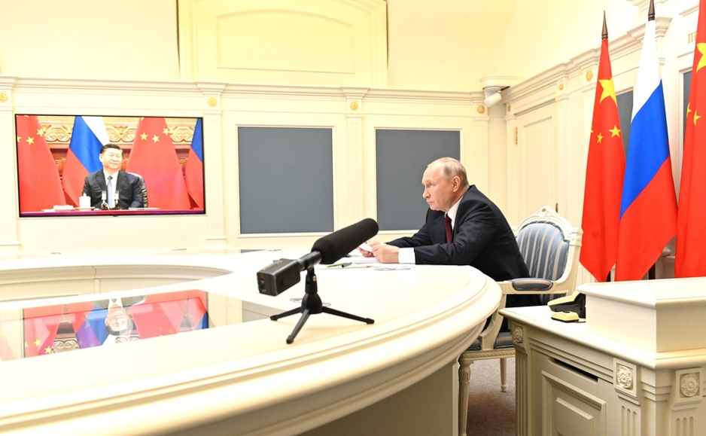

Russian President Vladimir Putin participates in a videoconference with Chinese President Xi Jinping (Source: President of Russia)

Diverging Trajectories and Incongruent Interests

Ties between China and Russia have been growing since 2005, when the long-standing border dispute was finally resolved, but the strategic partnership really took off in 2014, when Russia entered into a profound confrontation with the West caused by its aggression against Ukraine. In May 2014, Putin travelled to Shanghai to sign a deal to export large volumes of Russian gas to China, but the main thrust of the newly-launched proto-alliance (as important as energy matters were) was centered on joining forces to oppose US “hegemony” and it’s reshaping of the international order. The question of status in this clearly asymmetric bilateral relationship was of crucial significance for Moscow, and if in the beginning Russian experts still entertained the proposition that Russia qualified as a “big sister” for China, some five years later Foreign Minister Sergei Lavrov sought to disprove the perception that China had become Russia’s “big brother” (Lenta.ru, February 20, 2015; Izvestiya, September 5, 2019).

Taking a common stance, typically more declarative than practical, against the US’s policy of upholding global leadership does not ensure harmonization of Russia’s and China’s objectively dissimilar interests in many regions. For example, in the Arctic, Russia’s core interest is asserting its sovereignty, and it relies heavily on military means to do so, whereas China perceives the High North as a “global commons” and is not interested in its militarization (ICDS, September 3). Moscow’s prime interest In the Middle East is oil prices, so Russia has joined forces with Saudi Arabia to curtail the output through the OPEC+ mechanism (Bloomberg, September 12). By contrast, China is interested in securing high volumes of energy supply at the lowest possible prices. Syria is the linchpin of Russian interests in the Middle East, and the stability of al-Assad regime is threatened by the economic desolation, but China has hitherto shown only tepid interest in investing in Syria’s post-war reconstruction (The Conversation, July 30).

Russia is struggling to play a role in the Indo-Pacific, despite the region’s economic and geopolitical importance. Its relations with Japan have hit a rock with the Kuril Islands territorial dispute, the old friendship with India has weakened, and arms sales to Vietnam are curtailed because of objections by Beijing. In Moscow, the formation of a new security cooperation grouping between Australia, United Kingdom, and United States (AUKUS) is recognized as a major geostrategic development that requires rethinking of the prospects of the Russia-China partnership (Carnegie.ru, September 29). Nuclear submarines that Australia will acquire in some 10-15 years are of lesser concern for Russian experts than the spectacular increase of China’s naval capabilities. Russia cannot match China’s rapid naval modernization with its Pacific Fleet, which tries to show the flag as far as Hawaii, but has to concentrate its main efforts on protecting strategic submarine bases on Kamchatka (Nezavisimoe voennoe obozrenie, September 30).

For Russia, the pivotal theater in the irreducible confrontation with the West is Europe. The massive Zapad-2021 exercises demonstrated that much of Russia’s military modernization and reform is focused on preparing for a contingency on its Western flank (Moscow times, September 23). China is cautious not to get involved in this fluid balancing between containment and power projection, and abstains from providing any support to Russia in its stance on Crimea. A recent exchange between NATO Secretary General Jens Stoltenberg and Chinese Foreign Minister Wang Yi provides a bit of insight into current assessments in Beijing (NATO Press Service, September 27). Wang said that “NATO should stay committed to its original geographic location” essentially implying that China expects NATO to focus on the mission of containing Russia, and has no intention to interfere in this confrontation (XinhuaNet, September 28). Beijing and Moscow find it useful to downplay and deny multiple incompatibilities between their respective interests, but the hidden differences manifest themselves in the increasingly obvious failures to advance cooperation in many practical fields from public health to space exploration.

Marching to Different Beats

The official discourse on the ever closer China-Russia strategic partnership implies that practical cooperation between the two neighbors expands beyond the flow of oil and gas in one direction and consumer goods in the other; there are however, few signs of such progress in the fields that are of crucial importance to both countries. However, in the struggle with the COVID-19 pandemic, China and Russia have pursued entirely separate courses, even if Moscow takes particular care never to ascribe blame to Beijing for unleashing the global disaster (Australian Outlook, September 14). Russia was the first country to announce the breakthrough development of a vaccine, but its success story was undercut by slow domestic vaccination caused by widespread mistrust in the Sputnik-V vaccine (TRT World, August 18). China achieved greater success by exporting its vaccines to Latin America, Africa and South-East Asia, but data on the efficacy of Chinese vaccines remains dubious, and lack of transparency on its domestic health situation prompted India to align with Australia, Japan and USA and proceed with a counter-offensive in “vaccine diplomacy” in the QUAD format (Outlook India, September 28).

One area where greater bilateral cooperation would be mutually beneficial is space exploration. Russia used to compare its capabilities to deliver satellites into orbit and supply space stations with those of the US, but now finds only frustration in such comparisons. Russian propaganda tries to downplay the success of various US private space endeavors as billionaires’ hobbies, but what really caught Moscow by surprise was the spectacular advance of the Chinese space program (Russian International Affairs Council, October 7). China launched the first Tiangdong space station module, and deployed the BeiDou satellite navigation system, relying entirely on its indigenous technological base without any input from Russia (DefenseOne, July 16). Of course, Russia cannot ignore the military implications of these achievements. Russia expected that the new cosmodrome Vostochny constructed at huge expense (inflated by exorbitant corruption) would be of interest to China, but while visiting the still expanding construction site this summer, Putin observed the launch site is idle (EDM, July 15).

Beijing has shown limited interest in developing cooperation with Russia to enhance its strategic offensive/defensive capabilities, despite the potential boost this might provide. In October 2019, Putin delivered a big surprise at the annual Valdai club gathering announcing that Russia was helping China to build an early warning system, but since then only a few vague statements about “certain success” have been issued (TASS, August 24, 2020). It is possible that whatever plans for joint construction of the Voronezh-M/DM type early warning radars, have been impacted by the COVID-19 lockdowns (EastAsiaForum, November 20, 2020). However, China’s own buildup of its strategic forces has not slowed down, and the new data on China’s ICBM deployment has been a shock to many Russian experts (Nezavisimaya gazeta, August 29). The test of a Chinese hypersonic missile last August surprised many Western experts, but there is no evidence that Russia shared the technology used for the Avangard glide vehicle, which it deployed in 2021, after many years of research and development (Financial times, October 17; TASS, August 10).

China’s rapidly improving strategic capabilities underscore to Russia the limitations of the existing bilateral framework of negotiating strategic stability matters solely with the US, which Moscow values as a unique boost for Russia’s international prestige. It is no surprise that the Geneva consultations are not progressing well, as Russia clings to the principle of nuclear parity with the US and is unwilling to find a way to incorporate China into the equation (Kommersant, September 30). Moscow has thus far bowed to Beijing’s resolute refusal to join any arms control framework.

China’s consistent choice against engaging in any meaningful cooperation with Russia in areas perceived as crucial for its national security is determined not only by the desire to avoid any dependency, but also by doubts over Putin regime’s stability, which are informed by lessons learned from the USSR’s collapse. The Kremlin may have no such doubts regarding Xi Jinping’s grasp on power, but is anxious about the contrast in global perceptions between China’s rise and Russia’s stagnation.

Autocratic Partnership is Personal

Every decision on launching a major cooperative project is taken at the highest level in Moscow and Beijing, so the slackening of practical cooperation in the partnership may reflect a degree of unrealized estrangement between Putin and Xi. The two strongmen prefer to praise the unique chemistry of their friendship, despite the vast differences in their upbringing and political background, but the frequency of their contacts has visibly decreased, and Putin’s early announcement of his plan to attend the 2022 Winter Olympics in Beijing can hardly compensate for this shallowness of dialogue (RFERL, September 16). The crisis in Afghanistan has provided an important issue to engage on, but joint efforts at taming the Taliban are hardly in the cards as China relies on its power to invest in the region, while Russia stages a series of military exercises. The recent Shanghai Cooperation Organization (SCO) summit, which neither Xi Jinping nor Putin opted to attend, was rather disagreeable, with Tajikistan using its host privileges for making the case of ostracism against the Taliban regime (Nezavisimaya gazeta, September 14).

The pandemic has distorted many items that were on the agenda for Sino-Russia relations in the last couple of years. The long-planned celebrations of the 75th anniversary of victory in the Great Patriotic War in Moscow were abbreviated, but the celebrations of the 100th anniversary of the Chinese Communist Party in Beijing spared no expense (China Brief, June 19). Putin’s problem is that the Communist discourse and ideals are entirely foreign to his system of power, so much so that he can only refer to the 1917 revolution as a “tragic event” (Rossiiskaya gazeta, September 1). What is more disturbing from the Kremlin’s perspective, is the unrelenting struggle against corruption executed by Xi Jinping, as all-penetrating corruption is to all intents and purposes a key structural pillar of Putin’s regime. Exporting corruption may be Putin’s instrument of choice for building networks of devotees in Europe, but in China, his courtiers cannot find reliable counterparts. Xi’s purges of top security officials and the fierce behind-the-scenes power struggles are perfectly familiar for Putin’s court, but the revival of the Maoist slogan of “common prosperity” and exemplary punishment of billionaires are plainly incomprehensible to the Kremlin (Republic.ru, October 1). Many recent developments in China’s domestic policy appear to have left the Russian leadership puzzled. In Beijing there may be a better understanding of (and stronger expertise on) internal affairs in Russia, but what Xi Jinping learns hardly inspires confidence and trust in his partner.

Conclusion

Both Putin’s and Xi’s autocratic regimes are challenged by the US’s recent re-emphasis on bolstering democracy, but their common anti-American stance doesn’t make them natural partners, and it is possible that China-Russia strategic partnership has peaked. Both Moscow and Beijing are eager to argue that malignant US intrigues aimed at splitting their unity are doomed to failure, but the efforts of the Biden administration to impress upon Russia the imperative of “stable and predictable” behavior and to relaunch high-level dialogue with China provide little evidence that Washington harbors such grand intentions.

Strengthening NATO capabilities and tightening sanctions on Russia is unlikely to push Moscow closer to Beijing. The main focus of these policies is Ukraine and Crimea, and China has shown no intention of involving itself in this situation. Similarly, building resolve and capacity to counter China’s pressure on Taiwan is unlikely to prompt Beijing to expand ties with Moscow because the latter prefers to stay clear of the Taiwan issue, and has few means to engage with this escalating contestat in East Asia. Despite the rhetoric from Moscow and Beijing, an alliance of autocracies is not in the making, much as proletarians of all countries were never able to unite. Rather, it is the inherent uncertainty of each dictator in the durability of their rule that will largely continue to determine their actions at home and abroad.

Pavel K. Baev is a senior researcher at the International Peace Research Institute, Oslo (PRIO).

***

The US-China Hong Kong Sanctions Face Off

By Anouk Wear

Introduction

Since the Hong Kong National Security Law (NSL) passed on July 1, 2020, the US has sanctioned 42 individuals for their role in the imposition of the law. The People’s Republic of China (PRC) has responded with countersanctions targeting the US, and an Anti-Sanctions Law in the Mainland with similar legislation under discussion in Hong Kong. These tit-for-tat US-China sanctions are indicative of how Hong Kong, once a source of connectivity between the US and China, has become a growing source of contention in an increasingly fraught relationship.

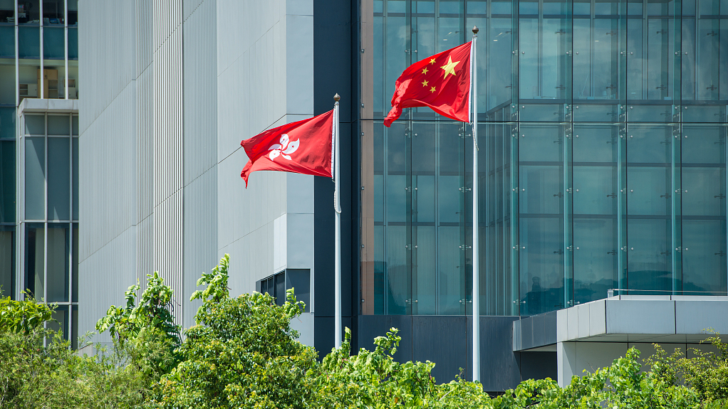

(The flags of Hong Kong and the PRC fly next to one another, Source: China Daily)

Legislation and Impact

The PRC’s National People’s Congress Standing Committee directly adopted an NSL for Hong Kong based on its powers under Article 18 of the Basic Law, Hong Kong’s de facto mini-constitution that implements the Sino-British Joint Declaration, thereby circumventing any input or consultation with the Hong Kong government. (General Office of the Standing Committee of the National People's Congress, June 30, 2020). Although many local people (including Hong Kong politicians) opposed the NSL, they did not have the political space or tools to effectively do so.

The NSL establishes the crimes of secession, subversion, terrorist activities, and collusion with a foreign country or with external elements endanger national security. These offenses can occur if a person simply “organizes, plans, commits or participates in any of the following acts [related to secession and subversion] by force or threat of force or other unlawful means with a view to subverting the State power” and “terrorism” is strategically left undefined. Furthermore, Article 38 has raised concerns surrounding extraterritorial jurisdiction over all non-Chinese citizens, as “[t]his Law shall apply to offenses under this Law committed against the Hong Kong Special Administrative Region from outside the Region by a person who is not a permanent resident of the Region” (Hong Kong Government, June 30, 2020). If broadly interpreted, this article could criminalize any criticism of the Chinese government by anyone, anywhere in the world. Despite concerns over the NSL’s ambiguity, there has not been an official clarification or guidance on the legislation from the PRC. This had led many observers to conclude that the NSL is intended to reduce civil and political space, including critique and dissent, at home and abroad.

In the first year since the NSL’s initial passage, Beijing has successfully established new offices and committees which ensure smooth monitoring and implementation of the law. These arrangements combine mainland and Hong Kong politicians and civil servants together, increasing Beijing’s direct role in local governance, and further eroding Hong Kong’s autonomy under “One Country, Two Systems.” The High Court’s first NSL verdict found that Tong Ying-kit (唐英杰) was guilty of inciting secession and terrorist activities. Tong was given a nine-year jail sentence, for driving a motorcycle with a flag reading “Liberate Hong Kong, revolution of our times” into three police officers during a 2020 demonstration (Hong Kong Free Press, July 30). Tong’s imprisonment show that the Hong Kong judiciary is keen on strictly implementing Beijing’s NSL too. Other NSL cases, such as Jimmy Lai’s ongoing trial on national security charges, where the maximum penalty is life imprisonment (Hong Kong Free Press, June 15), reveal that many of the worst fears surrounding the NSL are becoming a reality. For example, after Lai was arrested, the International Press Institute condemned the move stating it “further confirms what we already knew: the PRC’s so-called ‘national security’ law was imposed as a tool to abolish fundamental freedoms in Hong Kong, chief among them press freedom” (IPI, June 17).

Sanctioned Individuals
From August 7, 2020, until July 16, 2021, the US Department of the Treasury sanctioned 42 individuals for their roles in the imposition of the NSL invoking the Hong Kong Autonomy Act of 2020, Hong Kong Human Rights and Democracy Act of 2019, the Global Magnitsky act and a series of executive orders on Hong Kong
(US Department of the Treasury, August 7, 2020; US Consulate General Hong Kong & Macau, November 9, 2020; US Department of the Treasury, December 7, 2020; US Consulate General Hong Kong & Macau, January 15; US Department of the Treasury, July 16). Among these, all 14 Vice Chairpersons of the National People's Congress (NPC) of the PRC were sanctioned, while the rest were Hong Kong-based politicians and civil servants. The PRC responded that this was an “outrageous, unscrupulous, crazy and vile act” which will “trigger greater indignation” (Embassy of the People’s Republic of China in the Kingdom of the Netherlands, 8 December, 2020).

The US has now sanctioned nearly all the officials directly linked to the NSL but has refrained from acting against the most senior level officials who oversee the PRC’s policy toward Hong Kong. For example, while others in the NPC leadership were subject to sanctions, NPC Standing Committee Chairman and Politburo Standing Committee Member Li Zhanshu, was not sanctioned (Bloomberg, December 10). Vice Premier and Politburo Standing Committiee Member Han Zheng who leads the Central Leading Group on Hong Kong and Macau Affairs (中央港澳工作协调小组, zhongyang gangao gongzuo xietiao xiaozu) has also evaded US sanctions, as has General Secretary Xi Jinping. The US then also issued a business advisory, emphasizing that the legal landscape, specifically that the NSL, “could adversely affect businesses and individuals operating in Hong Kong. As a result of these changes, they should be aware of potential reputational, regulatory, financial, and, in certain instances, legal risks associated with their Hong Kong operations.” (US Department of the Treasury, July 16).

Countersanctions and Anti-Sanction Laws
In response to the US sanctions, the PRC imposed sanctions on 46 American nationals (FMPRC, August 10, 2020; FMPRC, January 21; FMPRC, July 23). The PRC argues that doing so is a way of treating the US in a way that is equal, and hence reciprocal, to what it has been subjected to. However, the sanctioned people are not directly involved in the US sanctions on the PRC nor are they critics of the NSL. Rather, the sanctions appear to be an opportunity for PRC retribution against to individuals that it dislikes. The PRC blamed “anti-China politicians” and “selfish political interests and prejudice and hatred against China” as the reasons for US sanctions (FMPRC, January 20) and claimed that the US “severely violates basic norms governing international relations” and interferes in the PRC’s internal affairs (Embassy of the People’s Republic of China in Finland, August 8, 2020). However, the PRC has never directly responded to the critiques of the NSL or its human rights violations in Hong Kong.

Additionally, on June 10, the Standing Committee of the NPC passed an Anti-Foreign Sanctions Law (The National Congress of the People’s Republic of China, June 10) which was domestically framed as a necessary countermeasure against unfair sanctions on the PRC (Xinhua, June 11). The law provides for three categories of countermeasures, which are related to visas, entry into the PRC, and deportation; sealing, seizing, and freezing property and assets; and prohibiting sanctioned individuals from conducting transactions with domestic organizations or individuals (The National Congress of the People’s Republic of China, June 10). The passage of the Anti-Sanctions Law also furthers the PRC’s narrative that Western countries are unfairly and unjustifiably smearing their policies, which explains this reaction. However, the impact is small due to the number and type of people affected.

Beijing also drafted an Anti-Sanctions Law for Hong Kong, but the vote on the legislation was postponed (South China Morning Post, 20 August). As Hong Kong is already the subject of a US business advisory, the Anti-Sanctions Law could further squeeze the business sector by precluding Hong Kong businesses from doing business with American businesses and financial institutions.

Conclusions
The NSL violates the PRC’s obligations under the Sino-British Joint Declaration, the basic law, and international human rights law, specifically the Universal Declaration of Human Rights and the International Covenant on Civil and Political Rights (UN Office of the High Commissioner for Human Rights, September 1, 2020). Nevertheless, the international community has few tools available to compel the PRC to desist from its roll back on civil and political rights in Hong Kong, and although sanctions on individuals may sting, cannot fundamentally alter the situation in Hong Kong

However, the PRC’s response threatens to further attenuate US-China economic ties in an already increasingly strained relationship. Its targets are seemingly random, and the PRC has not provided convincing justifications for its choices. In a landscape with many other politically motivated restrictions and regulations that are already impacting US businesses, the countersanctions and Anti-Sanctions Law may further constrain transactions between US businesses and their Chinese and Hong Kong counterparts.

Anouk Wear is a researcher and translator focused on human rights in the China region. She obtained her BA in Social Anthropology from the University of Cambridge and her Advanced LLM in Public International Law with a specialization in Peace, Justice, and Development from Leiden University.

Notes
[1] Constitution of the People's Republic of China, Article 66.

***

