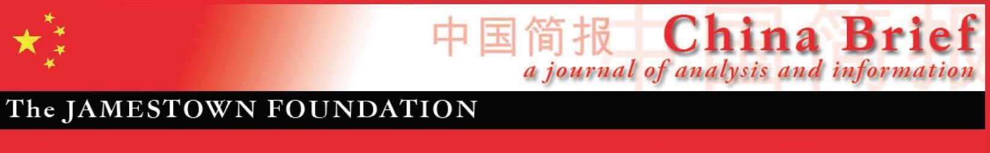
Volume 23 • Issue 2 • February 2, 2023

In This Issue:

Bleak New World: American Society In China’s Official Narrative
By John S. Van Oudenaren …………….…....………......…….......pp. 1-5

China’s New Historic “Leap” Narrative: Coverup for the Zero-COVID Policy Failure?
By Dominik Mierzejewski ….………….........................................pp. 6-11

In Kazakhstan, Generation Z on Alert Over China
By Berikbol Dukeyev ……………….…........................…..............pp. 12-15

Xi’s Anti-Corruption Campaign: Yunnan Province in Focus
By Naina Singh ….……………………..............…………..….......pp. 16-20

China’s Interests in North Korean Denuclearization: Reducing the Northeast Asian Security Dilemma
By Debalina Ghoshal....................................................................pp. 21-24

Bleak New World: American Society In China’s Official Narrative

John S. Van Oudenaren

Earlier this month, People’s Daily, the official newspaper of the Chinese Communist Party’s (CCP), ran an article by its Washington correspondent entitled “America’s Intractable Illicit and Pharmaceutical Drug Abuse Problem” (People’s Daily, January 6, 2023). The piece claims that “more and more American adolescents are becoming addicted to marijuana” due to its legalization by many U.S. states. It also asserts that U.S. media generally believe that drugs and substance abuse have “deeply permeated the fabric of American society.” An impoverished neighborhood in Columbus, Ohio, is described as an urban wasteland, where “haggard drug addicts stagger past boarded-up storefronts and dilapidated houses.” One longtime opiate addict is quoted as having lost twenty friends to overdose deaths. In addition to covering the impact of the opioid epidemic on American society, PRC state media has also covered the U.S. homelessness crisis at length. Myriad articles and TV features highlight the large numbers of people living on the streets of America’s cities under “extremely poor living conditions with a lack of government assistance” (Beijing Daily, January 26; People’s Daily, October 21, 2021). A recent feature on state television described the “cold-blooded clearing of homeless tent camps” by local authorities in cities such as Los Angeles as commonplace but nevertheless controversial (CCTV, January 26). PRC state media generally characterizes the removal of such homeless encampments by local governments in the U.S. as “cold-blooded” (冷血) or “ruthless” (无情), but usually ignores other ways American cities have sought to address the homelessness problem, such as providing shelters, public health and employment services (Yangtse Evening Post, January 26).

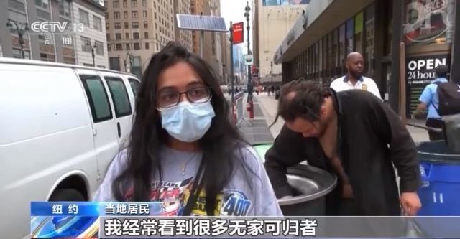

(Image: Screenshot of a CCTV interview with a New York City resident who said she often sees many homeless people on the streets, source: CCTV)

It is unsurprising that PRC state media outlets are extensively covering domestic challenges in the U.S. such as the homelessness crisis. In the two months since the rapid rollback of the zero-COVID policy in early December, COVID-19 has spread rapidly throughout China, inflicting a high death toll, particularly among the elderly (South China Morning Post [SCMP], January, 23). Since the Mao era, the CCP has sought to deflect attention from China’s domestic problems and bolster the image of its own system by highlighting internal problems in democratic societies, particularly the U.S. During the peak of the COVID-19 pandemic, with much of China’s population enduring extended lockdowns, negative coverage of the U.S. epidemic prevention response was relentless. In late 2020, a headline in one leading state-run tabloid blared, “During the Pandemic, America Has Become a Modern Version of Hell” (Huanqiu, December 6, 2020).

Blame Game

In the ongoing dispute between the U.S. and China over who bears responsibility for the fentanyl crisis in America, Washington has maintained that Chinese authorities must do more to stop the flow of fentanyl precursor chemicals to North America (China Brief, January 19). However, Beijing has countered that the U.S. has failed to address the demand side of the problem, the illegal drug use epidemic in America. Last summer, when China canceled counternarcotic cooperation with the U.S. as one of “eight countermeasures” in response to U.S. Speaker Nancy Pelosi’s visit to Taiwan, Rahul Gupta, the Director of National Drug Control Policy at the White House, tweeted that China suspending cooperation is “unacceptable” with the opiate epidemic claiming over 100,000 lives in America in the previous year. In response, PRC Foreign Ministry Spokesperson Wang Wenbin retorted that “the root cause” of the crisis lies in the U.S. He noted that the U.S. has just five percent of the world’s population, but is responsible for around 80 percent of global opioid consumption (PRC Foreign Ministry [FMPRC], August 12, 2022). Wang asserted that “the U.S. government has lost effective control over the management of prescription drugs” and that “public awareness on the harm of narcotics is lacking.” He concluded that “the U.S. must look squarely at its own problem instead of deflecting blame.”

PRC law prohibits recreational drug use of any kind and public attitudes towards illicit drug use are generally highly negative. Hence, PRC sources tend to characterize the widespread use of pharmaceutical drugs in America and cannabis legalization at the state level as evidence of U.S. laxity on drug enforcement. In a 2019 report on “The U.S. Opioid Crisis and Sino-U.S. Drug Control Cooperation,” the China Institute of International Studies (CIIS), a think tank under the Ministry of Foreign Affairs, traces the origins of the U.S. opiate epidemic to the 1990s, when Americans began to use pharmaceutical opiates in large quantities. According to the report, this increasing usage was the result of intensive lobbying by the pharmaceutical industry and government promotion of medicinal opiates (CIIS, May 19, 2019). A 2021 Xinhua feature on the many “social ills” in the U.S. states that as drug abuse deaths have soared by 30 percent during the pandemic, the U.S. government has vowed to crack down on the problem, but in reality, due to the lobbying by various interest groups, authorities actually condone or even encourage drug use (Xinhuanet, July 10, 2021).

A Land of Contradictions

Even at the height of America’s unipolar moment in the early 1990s, CCP elites saw the U.S. as a deeply divided society. In his 1991 book America Against America (美国反对美国), lead CCP theorist Wang Huning, observed that despite all its power and dynamism, America is a country riven by “antagonistic contradictions” (矛盾) divided along ethnic, social, religious and political fault lines. The book, which is based on Wang’s travels and experiences as a visiting scholar at the University of Berkeley in California in 1988, characterizes America as a land full of “paradoxes.” In Wang’s account, America is a “rich country that is full of poor people; a democratic country that is not fully democratic; a developed country with many educational problems; a country where equality is celebrated but not practiced; and a supposedly stable society that is actually in crisis” (AAA, 1991). However, he goes further than just listing what he views as the inherent contradictions in U.S. society. Rather, in the context of Marx’s edict that “capitalism is its own gravedigger,” Wang asserts that it is necessary to understand the complexities of the U.S. in order to exploit its fissures and vulnerabilities. "My idea is to use the real America against the imagined America," he writes.

The view that the gap between America as an ideal and America in practice has become a line of attack for China's external propaganda organs in recent years. In doing so, the CCP has sought to make the case that the U.S. support for a rules-based order, human rights and political pluralism is motivated not by principle but by self-interest.

Who Defines Human Rights?

The U.S. has criticized the PRC for its poor human rights record, with the situations in Xinjiang, Tibet and Hong Kong drawing particular opprobrium of late. Official censure has been accompanied by a growing array of Congressional legislation, such as the 2021 Uyghur Forced Labor Prevention Act (Congress.gov). Beijing has responded by falling back on its longstanding dictum that international relations must be based on respect for sovereignty and non-interference in states’ internal affairs (Xinhuanet, September 2, 2020). In doing so, the PRC has sought to cast the U.S. and a small coterie of its allies as weaponizing democracy and human rights. For example, in 2021, the PRC Ambassador to the UN Zhang Jun responded to a United Nations General Assembly debate on a resolution to condemn human rights abuses in Xinjiang stating that “in the name of democracy,” the U.S. and a few accomplices, “have been trying to get rid of those who dare to hold different views...But all their attempts will end in vain. Democracy is not a few countries' privilege, but a right enjoyed by people of all countries” (PRC Mission to the UN, October 21, 2021). Zhang also questioned the U.S.’s credibility to stand as an authority on human rights. He claimed U.S. criticisms of China serve to “cover-up” its “own terrible human rights record. But the world sees it clearly. The U.S. conducted genocide against American Indians. The US suppressed its own people to the point they have to yell ‘I can't breathe’." The latter point underscores that the PRC seeks to present racial disparities in the U.S. as evidence of American hypocrisy on human rights.

In its public diplomacy on Xinjiang, the PRC has made some headway in enlisting many states in the Global South to endorse the fiction that the extensive evidence of systematic human rights abuses in Xinjiang constitutes a Western disinformation campaign to undermine China (Xinhuanet, June 21, 2022). For example, this past June, 69 “cross-regional countries,” led by China’s long-standing co-communist partner Cuba, delivered a statement to the United Nations High Commissioner for Human Rights stating that “Xinjiang, Hong Kong and Tibet related issues are China’s internal affairs. We oppose politicization of human rights and double standards, or interference in China’s internal affairs under the pretext of human rights” (Xinhua, June 15, 2022). In January, a delegation led by Dr. Ali Rashid Al-Nuaimi, chairman of the World Muslim Communities Council, comprising 30 Islamic leaders from 14 countries, undertook a kind of Potemkin tour of Xinjiang (CGTN, January 11). During the visit, Al Nuami endorsed the PRC’s dubious presupposition that Uyghur “terrorist forces,” such as the East Turkestan Islamic Movement (ETIM) threaten China (China Brief, February 11, 2022).

As part of the PRC’s efforts to cast the U.S. as a duplicitous abuser of human rights, the State Council Information Office (SCIO) releases a yearly report on “Human Rights Violations in the United States.” The most recent report, which was released last February, states that in 2021 the U.S.’s “notorious” human rights record worsened (SCIO, February 28, 2022). The report charges the U.S. with numerous violations, including discrimination against minorities, mass incarceration, disregard for public health and failure to protect citizens from rising criminal and political violence. For example, the report states “the elderly' rights to life are flagrantly violated” in the U.S. with American politicians following “the natural law of ‘selecting the superior and eliminating the inferior.’” The report cites as evidence the half-a-million elderly Americans who died due to COVID-19, quoting a UN expert who observed that “discrimination in the delivery of health care services, insufficient prioritization of nursing homes in responses to the virus, and lockdowns left older people more vulnerable to neglect or abuse” during the pandemic.

Conclusion

The CCP has long sought to project a negative depiction of America to its domestic audience in China. However, as the PRC’s ability to influence the global information environment has increased, its external propaganda apparatus has also peddled this narrative to an international audience. While Washington may be tempted to disregard such efforts as mere “whataboutism,” this would be shortsighted. Instead, the U.S. should recognize that it faces an increasingly contested information environment, particularly in the Global South, which could have far-reaching ramifications. As the recent Russia-Ukraine war has shown, many countries in Africa, Latin America, South Asia and the Middle East are willing to turn a blind eye or even abet Moscow’s aggression due to self-interest, fraught relationships with the West, or both. If current attitudes toward the U.S. and China are indicative, efforts to rally international support for Taiwan in the event of PRC aggression might encounter similar headwinds.

John S. Van Oudenaren is Editor-in-Chief of China Brief. For any comments, queries, or submissions, please reach out to him at: cbeditor@jamestown.org.

China’s New Historic “Leap” Narrative: Coverup for the Zero-COVID Policy Failure?

Dominik Mierzejewski

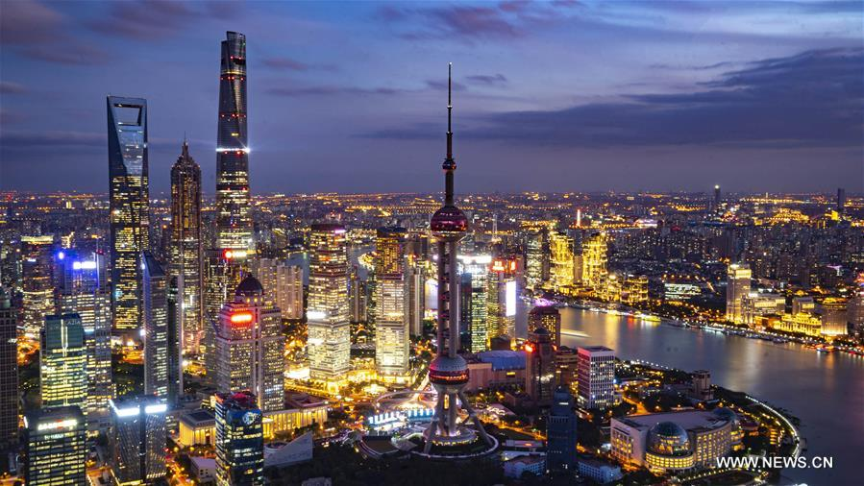

(Image: The Shanghai skyline at night, source: News.cn )

Introduction

With Chinese authorities having shifted away from a zero-COVID policy at the end of November, the country now faces an unresolved dilemma as to its future approach to economic development and public health policies. A critical question is: will the Dengist doctrine of "Reform and Opening-up" return to the political discourse? But the most critical issue revealed by People's Daily is how Chinese propaganda has portrayed the recent chaos, as well as how it has promoted General Secretary Xi Jinping's image in spite of the failure of the zero-COVID policy. These questions are of particular importance ahead of the second plenum of the 20th Party Congress, which is planned for February 2023. A brief analysis of the theoretical section of the People’s Daily, “An Intersection of Thoughts” (思想纵横), throughout December 2022, may offer some preliminary answers. The critical points introduced in People's Daily indicate how China is likely to be led moving forward, with major features such as governing within a "one way" approach and a Chinese-style modernization process representing what is seen as a rational path of development going forward.

How Will China be Governed?

The first important signal found in People’s Daily indicates that China’s development is seen as perpetual, never ending and in constant flux. On the one hand, taking this approach as a basic perspective, party members and the general public should understand the nature of these changes, seek after changes and respond to these changes. This approach had previously justified the zero-COVID policy as necessary, although omitting any mention of lockdowns across the country or their impact on the national economy.

In the official account, comprehending shifting circumstances requires a scientific approach and ought not to be "disordered" (杂乱无章). Effectively responding to changes entails a conscious understanding that reform and innovation will never end. In order to promote the continuous and in-depth development of reform, it is necessary to take firm actions while "keeping a cool head" and exercising strategic sobriety (战略清醒). However, rather than merely being passive observers, the people should actively promote reforms. At the beginning of December, People's Daily urged people to actively seek changes and create new opportunities (People's Daily, December 1, 2022).

Encouraging people to do more aligns with the discussion about the role of the market and the state in the development of the national economy. The responsibility for governing the party and the people is placed on the party members, who should focus more on the institutional dimension. Although the role of bureaucratic cycles is important, it does not mean that the market always prevails. Nevertheless, the market still has a decisive role to play in resource allocation. In this context, the role of the state is to serve as a lead actor in the redistribution of wealth, allowing the market to participate in China's economic development. As stated by the Chinese media, economic development is only possible by creating strategic national scientific and technological strength, as well as through the promotion of continuous progress in self-reliance and self-improvement, both in science and technology, which are controlled by the government (People’s Daily, December 8, 2022). In this regard, recognition of the theory and thoughts as leading forces within the party and the state are important, as is theoretical innovation. In announcing this approach, however, Xi has not rejected the development model of Deng Xiaoping. In fact, People's Daily announced that in this new era and a new journey, the government will continue to promote theoretical innovation based on practice and continue "to write a new chapter in the modernization of Marxism in China, which cannot be separated from the guidance of scientific thinking, a scientific worldview or methodology" (People's Daily, December 2, 2022).

This approach to reform, however, should not be seen as adequate for governance alone. In order to win the technological competition with the West in the fields of information and biomedicine, an effective organizational model of coordination as well as scientific and technological innovation must also be introduced as soon as possible (People's Daily, December 8, 2022). However, promoting Xi’s ideas as the guideline undermines Deng’s logic of practice—a true dichotomy. Now, the efficiency of this approach depends on the world outlook and methodology of Xi Jinping Thought on Socialism with Chinese Characteristics for a New Era. Xi's method or fangfalun (方法论) generally refers to the means and behaviors, which are adopted to obtain something or to achieve a certain purpose by following the masses, without precise instructions from the central leadership (People's Daily, December 2, 2022). This superficial advice holds that party members should "always maintain flesh-and-blood ties with the people" and follow the views of the masses, constantly helping them to achieve a better life. Interestingly, the party should "constantly realize, maintain, and develop the fundamental interests of the overwhelming majority of the people," meaning that China should predominantly focus more on the less developed rural areas in China. But as described by the "Intersection of Thoughts" section, the Chinese Communist Party (CCP) is the vanguard of the Chinese working class, as well as the Chinese people and the Chinese nation. These Maoist-style narratives center on the supremacy of the people, which "is one of the historical experiences of our party's century-old struggle" (People's Daily, December 6, 2022).

"One Way" Forward

Although the masses are correct, Xi Jinping is even "more correct." Articles published in People's Daily with the title ending in the "only way" (必由之路) refer mainly to Xi’s thoughts and the position of the core leadership. This concept holds that since 2017, under Xi's leadership, "the country has adopted a series of strategic measures, promoted a series of transformative practices, achieved a series of breakthroughs, as well as a series of landmarks results". Furthermore, the country's economic strength has achieved "a historic leap to a higher position" (历史性跃升) (People's Daily, December 12, 2022).

The vocabulary describing this economic situation as a historic leap, is reminiscent of the propaganda from the Great Leap Forward (大跃进) period, although, at least for the moment, Chinese propaganda has resisted labeling this period a “New Era.” Nevertheless, as People's Daily is now placing da yuesheng (大跃升), a great leap, in a higher position within its articles, this rhetoric may well be adopted in the future. However, the announcement of an economic leap to a higher position needs to be justified. In this matter, the zero-COVID policy helps, as the worse the current position of China's economy, the more marked the economic recovery and success that follows will be made out to be. At the same time, according to Chinese propaganda, the national governance system and governmental capabilities have been significantly improved. "One way" means that the party's leadership is the only way to uphold and develop socialism with Chinese characteristics through unifying the whole country under the party banner, "a solid piece of steel" (一块坚硬的钢铁) (People's Daily, December 12, 2022).

The critical issue is to rectify and consolidate the source of this development. The publication goes on to declare, "With the great historical initiative, great political courage, and strong responsibility, we have adopted a series of strategic measures." All approaches promoted a series of transformative practices, and the historic achievements provided a more complete foundation for the realization of the great rejuvenation of the Chinese nation. This in turn is declared to lead to the realization of the great rejuvenation of the Chinese nation, which has entered an irreversible historical process (不可逆转的历史进程). According to the People’s Daily theoretical page, the Chinese Communist Party (CCP) and the Chinese people are confidently promoting the great leap to a higher level (伟大飞跃) of the Chinese nation by standing up, getting rich and becoming strong (People's Daily, December 13, 2022).

The official narrative holds that rejuvenation is only possible through unity, and struggle is the most significant spiritual symbol of the Party and the Chinese people. An oft-repeated mantra is that over the long course of history, the Chinese people have united as one and worked together to forge (铸就了) the great Chinese civilization that has lasted for thousands of years (People's Daily, December 14, 2022).

An important observation that illustrates the logic of "one-way" is the need for the redefinition of the Deng era. The People’s Daily states that development is an ever-changing process and that the current, export-oriented development strategies have exhausted all possible levers for growth. While China is losing its comparative advantages in resources and labor, the environment and conditions for economic development have undergone profound and complex changes in the new era. In this regard, the race for economic growth has caused many problems and challenges along the way, including "the increased prominence of unbalanced, uncoordinated, and unsustainable development, which manifests in extensive development methods, weak innovation capabilities, unbalanced development between urban and rural areas, and resource constraints." This situation requires that the Chinese government promote an economic development shift from high-speed growth to high-quality development and solve the long-term accumulation of unbalanced and insufficient economic and social development (People's Daily, December 15, 2022). In order to fulfill the aforementioned promises, the only possible way is to trust the party to have the courage to revolutionize itself and fulfill the promise that the Chinese nation will have a long and bright future. The People’s Daily then states that the party needs to manage the structure in a very strict manner, always maintaining the party's advanced nature and purity through anti-corruption campaigns that serve the purpose of "eliminating diseases and governing (curing) any chaos” (祛疴治乱) supported by disciplinary meetings within the party structure (People's Daily, December 5; People's Daily, December 16, 2022).

Realizing The Chinese-Style Modernization Miracle by Opposing the West.
The last point raised by the theoretical sections of People’s Daily is the need to achieve an understanding of Chinese-style modernization, which is contrasted with the Western development model and intended to act as an example for the developing world. Any environmental issues created during this time are simply an inescapable consequence of this dramatic transformation and were also part of previous leaderships’ policies.

A key theme is that Chinese-style modernization is a "miracle," which is unprecedented in history and makes a special contribution to the future concept of the development of humankind. More to the point, this process is not based on either a single modernization model in the world or a universal modernization standard (定于一尊). In other words, countries in the Global South should try to reform themselves in their own particular way based on their respective, local circumstances. In the context of China, modernization adheres to the people-centered development philosophy, promotes common prosperity through high-quality development, supports whole process people's democracy, enriches the people's spiritual world, promotes the sustainable development of the Chinese nation, and interacts positively with the world and cooperates for win-win results. This approach is illustrated by self-proclaimed opposition to the old western modernization of capital-centered modernization, polarized modernization, materialistic modernization and external expansion and plundering. People's Daily adds that China's modernization also expands the path for developing countries to modernize (People's Daily, December 19, 2022). China has abandoned its old modernization path of foreign aggression as well as expansion and always advances modernization based on the path of peaceful development. People's Daily praised the speed and efficiency of China's development, saying that to industrialize, a process that took developed countries centuries, has taken China mere decades. Moreover, during this span, China has achieved two miracles: rapid economic development and long-term social stability. The great achievements of Chinese-style modernization "are not due to anyone's gift, nor do they rely on foreign military expansion and colonial plunder, but are made by the Chinese Communist Party and lead the Chinese people to rely on self-reliance and hard work." Moreover, the narrative claims that that peaceful policy of win-win cooperation, embracing the world, learning from the world, and contributing to the world, has been part of the China story (People's Daily, December 26, 2022). More than this, western development over more than 200 years had gone through "the pollution period" first and has tried to resolve the environmental issues...while creating huge material wealth, they have also accelerated the plundering of natural resources and brought serious ecological and environmental problems creating deep-seated contradictions between the people and the environment. Since the 1930s, many environmental incidents have occurred in Western countries, one after another, causing huge losses that "shocked the world" (People's Daily, December 23, 2022).

The articles seek to make the case that Chinese-style modernization theory not only aligns with China's reality, but also embodies the laws of socialist construction and the development of human society. People’s Daily claims this theory enables mankind to have a new understanding of modernization issues and shows a new direction and bright prospects for modernization (People's Daily, December 19, 2022). Even though this narrative should be understood as China's ambition to showcase this universalistic development model, the economic “miracle” has also generated challenges. Interestingly, due to its large population, China's development faces immense environmental pressures and resource constraints. As a result, in order to achieve modernization, the Chinese "must embark on a path different from that of Western countries" (People's Daily, December 20, 2022). The December 23 “Intersection of Thoughts” article claims that one of the major contributions of Chinese-style modernization to human modernization, in general, is that it has been proved in practice that economic development and ecological and environmental protection exist in a dialectical, unified and complementary relationship. Building an ecological civilization and promoting green and low-carbon circular development can meet the growing needs of the people (People's Daily, December 23, 2022).
However, what is now critical for the CCP is determining how to respond to the current times of rapid change, which are characterized by an increasing absence of peace, development, security, and governance. People’s Daily sometimes uses the metaphor of a "giant ship" for China that can cleave through the waves and forge ahead in an indomitable manner under the banner of socialism with Chinese characteristics (People's Daily, December 26, 2022). The paper also sees the Chairman as a "great helmsman" without whom the country would collapse (People's Daily, December 22, 2022). As Xi Jinping is an inexperienced economist and practitioner, studying theory has been given priority and should guide practice. Promoting Chinese-style modernization is a long-term and arduous social revolution that cannot be separated from the guidance of scientific theories (People's Daily, December 19, 2022).

Conclusion

According to general popular belief, the Chinese system operates better within a dictated framework than through coordinated politics. However, the zero-COVID lockdowns illustrated that neither the top-down framework nor the coordinated model of governance worked to the degree that the central government desired. As the theoretical section of People’s Daily does not directly address the zero-COVID policy, but rather only incentivizes its readership with the promise of an upcoming “leap to a higher position,” one might be tempted to suggest that the last three years of lockdowns, which brought major economic disruption to the country, have been artificially created in order to portray Xi as the great savior of the country.

As state planners in Beijing have predicted, the economic slowdown engendered and deepened by the Zero-COVID policy, might soon reverse, becoming a more eye-catching economic recovery, with propaganda successfully translating this conception into reality. Furthermore, the country's Zero-COVID failure which was unsurprisingly not directly mentioned in "An Intersection of Thoughts," will be utilized by CCP propaganda to give the chairman an honorary position in Chinese history and declare that China's economy has begun to "leap to a higher position." The Zero-COVID policy, as framed by Chinese propaganda, could be presented as a historical challenge that was only met under Xi’s guidance and leadership, thereby allowing the country to "conclude a historical period and enter a new era." However, as revealed in the "An Intersection of Thoughts" section of People’s Daily, the most significant issue for Chinese-style modernization is environmental pollution. In this regard, apart from the economic recovery being named a "leap," the environmental issue may be presented as Xi's biggest theoretical input to Marxist-Leninist doctrine.

The development-environment nexus within the current dialectical approach, as introduced in People's Daily, allows the Central Party School to organize the new narratives about Xi's contributions to the universal logic of socialism. However, this is not merely a propaganda problem. The environmental quandaries are listed in the 14th Five-Year Plan (FYP) with seven out of eight binding indicators concerning environmental protection, e.g. reducing carbon dioxide emissions and per capita energy consumption (Gov.cn, March 13, 2021). The second major issue ahead of the Second Plenum is to stimulate domestic consumption and promote high-quality development, thus ensuring more ways to redistribute wealth among the people. However, as the economic data shows, domestic consumption has fallen over the course of 2022. Retail sales were down 5.9 percent year-on-year in November 2022, and the increase in per capita consumption had slowed to just 1.5 percent year-on-year growth in the third quarter of 2022 (China Briefing, December 26, 2022). This means that this "new leap" could involve encouraging people to take more responsibility for the country's development and leaving the market to decide the allocation of resources, but with the government "keeping a tight rein on" strategic technology sectors, which guarantees the state a continued key role in China's economy.

----
This brief was prepared with a qualitative analysis of "An intersection of thoughts" (思想纵横) section published in "People's Daily" between December 1 and 31, 2022.

Dominik Mierzejewski: head of the Centre for Asian Affairs (University of Lodz); Professor at Department of Asian Studies at the Faculty of International and Political Studies (University of Lodz); Chinese language studies at Shanghai International Studies University; visiting professor at the Chinese Academy of Social Sciences in Beijing; the principal investigator in grants supported by the National Science Centre (Poland), Horizon 2020, Ministry of Foreign Affairs; specializes in the rhetoric of Chinese diplomacy, political transformation of the PRC and the role of provinces in Chinese foreign policy.

In Kazakhstan, Generation Z on Alert Over China

Berikbol Dukeyev

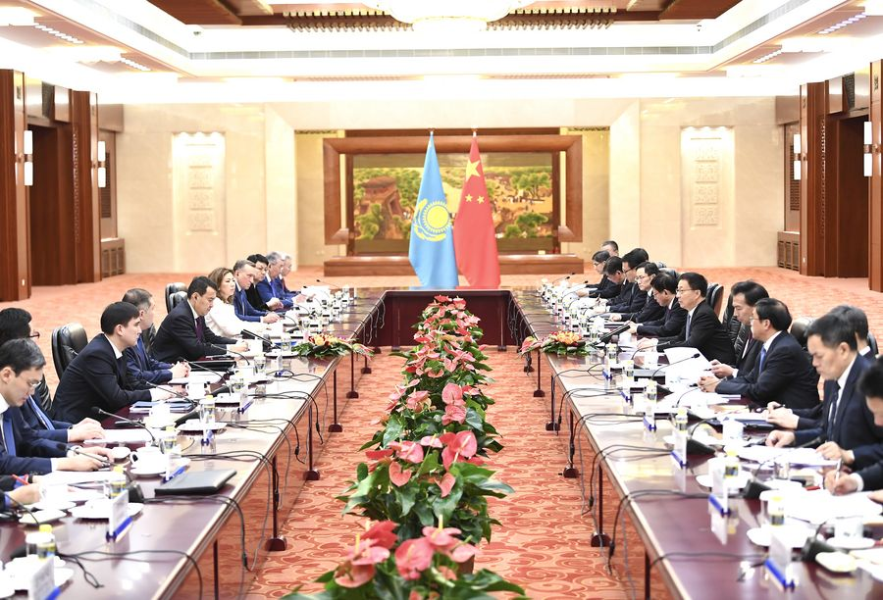

(Image: A meeting of China-Kazakhstan Cooperation Committee in late 2019 in Beijing, source: Xinhua)

Introduction

Kazakhstan is seeking to boost bilateral ties with China, which is reopening international travel after abandoning its Zero-COVID policy late last year (Kazinform, January 17). However, “Kazakh Gen Zs” born in the 2000s are worried about their country’s increasing dependency on China. [1] “China is our ally and [our] enemy, the villain, and thanks to this, [our] economic lives,” wrote a second-year student who has studied in one of the private universities in Kazakhstan’s largest city Almaty. The topic of China has evoked a wide range of thoughts and opinions from students, and a study of twenty essays on China written by Kazakhstani Generation Z reveals some of their more nuanced perceptions of China. [2]

Mixed Feelings

Across their essays, the representatives of Gen Z internalized the pragmatic balance promoted in Kazakhstan’s official foreign policy (President of the Republic of Kazakhstan, March 9, 2020). Sandwiched between Russia and China, Kazakhstan has endeavored to balance friendly relations with its close neighbors and with western countries in order to lessen the effect of its landlocked geography. Students expressed positivity about the fact that Kazakhstan borders one of the world’s most powerful economies, China. These students appreciated that the solid Chinese economy enables Kazakhstanis to conduct import business with China, receive quality Chinese higher education, and purchase cheaply produced consumer goods. Gen Zers, who grew up during the oil boom in Kazakhstan in the 2000s, are clearly inclined to support a booming market economy with a strong flavor of consumerist culture (Voices of Central Asia, March 21, 2019). Additionally, some students expressed a desire to travel, study and work in China. However, despite these perceived advantages, students felt pressured as Kazakhstan is located between two giants, China and Russia.

Gen Z was particularly concerned over the increase in Chinese investment in developing economies, including Kazakhstan, which they perceived might translate into political influence. They fear this will give leverage to Beijing and make Kazakhstan more economically dependent on China. The students expressed beliefs that China absorbs countries into its domain by lending to governments that are unable to repay these loans. These loans must be settled by other means. With Kazakhstan being the sixth largest recipient of Chinese loans, right after Angola, Brazil, and Indonesia, economic dependence is a matter of sovereignty concern (Aid Data, September 2021). Also, the students expressed concern about statements made by China, which views its neighbors with “pride and condescension.” Among many examples, a privately owned Chinese website Sohu ran an article entitled “Why Is Kazakhstan Eager To Get Back to China?” claiming that the Central Asian country was historically part of China and asserting that Kazakh tribesmen once pledged their allegiance to the Chinese emperor (VOA Chinese, April 15, 2020). In response, the Foreign Ministry registered its concern with the Chinese Ambassador Zhang Xiao over the story (Gov.kz, April 14, 2020).

The undergraduates who were surveyed also expressed concern over China’s competition with the West for “the world’s great power position” and over issues such as Taiwan, which pose a challenge to Kazakhstan’s multi-vector foreign policy that seeks to balance relations with Russia and China. Officially, Kazakhstan is committed to a “One China Policy” and considers Taiwan an unalienable part of China (The Astana Times, August 4, 2022). The students clearly regarded China’s growing confidence, its increasingly active role in the international arena and its growing global stature as worrisome developments for states that do not desire to follow China’s international lead.

Stereotypes Have Deep Hold

Despite these pragmatic views, Sinophobia is still apparent in the attitudes of Gen Z Kazakhs toward China. Some of the students used derogatory and offensive stereotypes to describe China and its people as spreaders of exotic diseases, eating insects, not being clean, and bringing “filthiness” to Kazakhstan. They also wrote that democracy and human rights are ‘alien’ concepts to China. They expressed dislike for China because of its unjust and cruel policies, including the surveillance of its people. The extent of corruption and nepotism at the top levels of Chinese politics and business was also raised. One student noted that Chinese workers face unemployment and low-paid working conditions due to their large population, equating conditions to “modern-day economic slavery.” Despite such negative perceptions, China remains attractive to students for short-term visits, but they do not wish to reside there permanently because of fierce competition in the job market. The students felt that China is a country that aggressively builds a positive image of itself and its development, but things are very different on the ground.

The aforementioned views of China also seem to have an implicit effect on Gen Z through their increased consumption of video content on social media. This potentially shows a lack of impact on Chinese soft power spending despite considerable funds allocated to cultural diplomacy in Kazakhstan. For example, one student wrote, “when we think of China, we can think of the huge population, dirty air, and cruel laws.” They disliked careless attitudes toward air pollution, useless waste and in particular, the gray smog in Beijing. Paradoxically, others tended to like strict laws and wished they could be applied in Kazakhstan, where the students perceived them as conducive to development.

Simultaneously, students were fascinated by China’s culture and considered its people creative and hardworking. Students recognized the great inventions of Chinese scholars, and Gen Zs often watched videos where Chinese people expressed themselves creatively. Students particularly liked the Chinese studious education system that seemly produces smart minds from early school years. Additionally, diverse cuisine, great movies, and technological advancements were all appreciated.

Conclusion

Not to be missed in their essays, the students particularly condemned the re-education programs of the Chinese Communist Party (CCP) being administered in Xinjiang. [3] Students were genuinely perplexed about how such cruelty could be perpetrated by a country against its own Muslim citizens. Students write that Muslims, including ethnic Kazakhs, have been beaten, imprisoned, or killed, and they assess the CCP policy towards the ethnic minorities of Xinjiang as morally inhumane (China Brief, May 15, 2018). They were also frustrated that the plight of those victims in so-called re-education camps had not received greater worldwide attention. Acknowledging the plight of those who have undergone treatment in re-education camps is an expression of solidarity with those who share similar Islamic identities. Accepting that China is a great world power with the world’s fastest-growing economy, students expressed caution about the growing dependence of Kazakhstan on China.

Berikbol Dukeyev, a native of Kazakhstan, completed his Ph.D. in politics and international relations from the Australian National University (ANU) in 2022. His research interest includes intersections of politics, society, and security. His publications appeared at OpenDemocracy and Central Asian Affairs. Previously, he was a Sessional Academic at ANU, a Central Asia Fellow at George Washington University, and a Research Fellow at the Institute for Strategic Studies under the President of the Republic of Kazakhstan.

Notes

[1] Paolo Sorbello, “The Sorrows of Kazakhstan’s Generation Z,” The Diplomat, January 30, 2018.

[2] The essays cited here are by first and second-year university students in Kazakhstan. The students produced handwritten essays on their views of China in December 2022 in Kazakh or Russian languages. These essays were written anonymously without collecting any identifying information.

[3] James Millward, “China’s New Anti-Uyghur Campaign How the World Can Stop Beijing’s Brutal Oppression,” Foreign Affairs, January 23, 2023.

Xi’s Anti-Corruption Campaign: Yunnan Province in Focus

Naina Singh

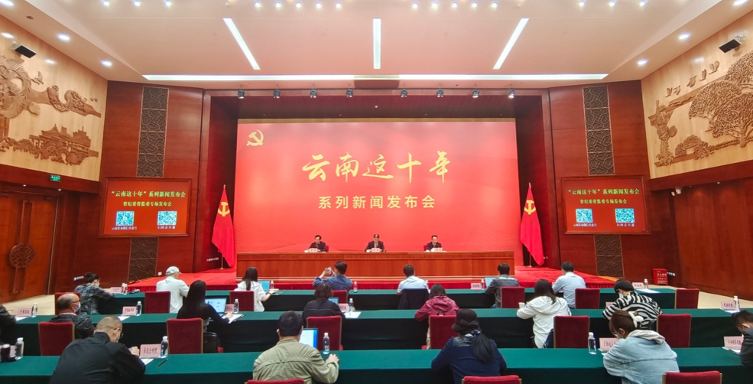

(Image: The Yunnan Province Commission for Discipline Inspection held a press conference in June 2022 on progress combating corruption in the province over the past decade, source: Yunnan.cn)

Introduction

At the 20th National Congress of the Chinese Communist Party (CCP) last October, General Secretary Xi Jinping lauded the achievements of his anti-corruption campaign, reminding the audience that a total of 207,000 “top leaders” (一把手) at all levels had been investigated by the discipline inspection and supervision organs across the country (Chinanews.com, October 17, 2022). This unprecedented crusade against corruption, which is predominantly seen as a survival and position-assuring exercise on the part of Xi, has also brought to light the cliquish “small circle culture” (圈子文化) in provincial politics, which has escaped central scrutiny for years. [1] During the reform and opening-up period, decentralization afforded the provinces greater autonomy in decision-making and control of fiscal resources. However, in many provinces, the leadership exploited this situation to strengthen their local political networks and harbor misconduct, thereby hollowing out the CCP from within. [2] Ultimately, it is Yunnan, the distant southwestern border province endowed with abundant natural resources that lies far from Beijing, that most resembles Minxin Pei’s "mafia state." [3]

Since the 18th Party Congress in 2012, in addition to eleven senior officials, or “tigers,” the province has investigated the highest number of department and division-level cadres (Chinanews.com, June 22, 2019). According to a press report in 2021, the province’s discipline inspection and supervision organs have filed 55,693 cases, disciplined 53,711 people, and investigated 418 cadres under provincial control in the past five years (Yunnan.cn, November 25, 2021). Several cases in Yunnan’s anti-corruption drive have highlighted deep-seated corruption in transportation, housing construction, social security, medical care and education. However, publicly owned assets such as land and mines topped the list in terms of graft. Various local media articles equate the “earthquake” striking Yunnan officialdom with the crackdowns in Shanxi and Inner Mongolia Autonomous Region, exposing the link between natural resources and corruption in China (People.cn, August 10, 2020; Boxun.com, March 20, 2015). Unlike the urbanization-centric rent-seeking in eastern provinces, the corruption in the “metal kingdom” has been dominated by the development of mineral resources and the tobacco industry. The public confession of Bai Enpei, former provincial Party Secretary of Yunnan, in the 2016 miniseries, Always on the Road (永远在路上), which was co-produced by the propaganda department of the Central Commission for Discipline Inspection (CCDI) and China Central Television (CCTV) put the Yunnan administration in the spotlight (People.cn, October 18, 2016). Nevertheless, Yunnan provincial and local officials’ dances with power, status and corruption go a long way back.

Western Development and Tryst with Corruption

Recently, Chinese writer and scholar Deng Yuwen (邓聿文) stated frankly that corruption has served as a lubricant for economic reform and development. According to him, alliances among elites and bribery were the norm during Deng Xiaoping-Jiang Zemin-Hu Jintao eras, when corruption was an open secret. [4] Yunnan, although underdeveloped in comparison to the east coast provinces, is not an exception. The southwestern province has long been sidelined as a remote frontier, with significantly less potential for economic growth. However, Yunnan is endowed with abundant raw materials and hydropower potential, but accessing these resources has been challenging. In the earlier days of reform, the western region suffered from a lack of capital investment, so industries such as tobacco, sugar, tea and the border trade with neighboring states drove the local economy.

The opening up of China’s economy during the 1980s had no significant impact on the western region. However, the administrative and management changes resulting from economic restructuring paved the way for increased provincial autonomy. Policy changes related to decentralization and market economy gave local leadership the opportunity to manage economic growth and personnel within their territory. Soon enough, the provincial leadership in Yunnan began to promote its economic appeal as the Southwestern gateway” (西南大门) to China’s South and Southeast Asian neighbors (Yunnan.cn, March 9, 2020).The provincial capital of Kunming has become a nexus for regional arrangements such as the ASEAN Free Trade Area (AFTA), Greater Mekong Sub-region cooperation (GMS) and the Bangladesh China India Myanmar (BCIM) initiative (ASEAN-China Centre, May 31, 2011). At the turn of the 20th century, the region also saw increased attention from Beijing under “Great Western Development Strategy” (西部大开发), which prioritized building up the infrastructural and transportation sectors in China’s underdeveloped west (Gov.cn, October 10, 2009). On the one hand, such upscaling aided socio-economic development in Yunnan and created regional opportunities for local state-owned firms; on the other hand, it opened a Pandora’s box for “collusive” corruption.

The first corruption case to rock the province was in 2003 and involved former Yunnan governor Li Jiating, who is of Yi ethnicity. Li was sentenced to death for taking 18.1 million yuan (US$2.2 million) in bribes beginning in the 1990s when he was first a vice governor and deputy party secretary and then governor until 2001 (Shaanxi Legal Network, February 22, 2022). The saga did not end there, as the imbroglio ended up being a family affair. The Standing Committee of the Central Commission for Discipline Inspection also charged Li with abusing his powers to seek illegal benefits for his son Li Bao and mistress Xu Fuying (Sina, May 27, 2003; China Youth Daily, December 16, 2004). Referred to as an “underworld beauty” (黑道美人), Xu was infamous for running a restaurant known to host gatherings of the leaders of Kunming’s criminal underworld and was eventually thrown in prison for her involvement with smuggling (China News Digest, 2003; ChinaNews.com, May 27, 2003). Another high-profile corruption case involved the former vice mayor of Kunming Hu Xing, who also served as deputy director of the Yunnan Provincial Transport Department. Hu took more than 40 million yuan ($ 5.3 million) in bribes while in charge of overseeing construction, roads, and city planning, the highest amount ever charged for graft in Yunnan (China Daily, August 8 2007). Although Li and Hu were both harshly punished, these measures did not stem the issue of corruption in Yunnan (GoKunming.com, April 26, 2010). A few years after Hu’s life sentence verdict, Zao Shiyong, the former party secretary of Malipo county in Wenshan prefecture, was charged with accepting 5 million yuan ($ 0.7 million) in bribes; the largest ever uncovered at the county level in Mainland China at the time.

Since 2010, the geostrategic importance of Yunnan has only grown in Beijing’s eyes. The province has been officially assigned a “bridgehead” role as China’s link to Southeast and South Asia, it has also assumed an important role in the southern leg of the Belt and Road Initiative (BRI) (PRC Ministry of Commerce, August 25, 2022; Xinhua, September 25, 2010). Still, a few observers view the corruption crackdown in Yunnan, which has been underway since 2014 simply as Xi’s attempts to strengthen personal control at the province level. However, the unearthed ecosystem of profiteering and deception created by the senior officials and nurtured by low-level officials, or “flies,” were a direct challenge to the CPP authority.

The Natural Resource Curse

The literature on “resource curses” lays out the greater potential for rent-seeking behavior in extractive industries if a government fails to define and enforce property rights properly. In China also, the combination of incentives such as the transfer of “control” and “use” rights of land and mines to local governments with the administrative power to allocate contracts and capital has been the leading cause of crony capitalism among provincial officialdom. Yunnan’s reserves of resources, in particular lead, zinc, copper and tin, are among the most extensive in China and have become a central talking point in the anti-corruption drive. The puzzle surrounding the role of minerals in provincial corruption started to unfold with the 2014 arrest and prosecution of former Sichuan Party Secretary and security chief Zhou Yongkang, who was also a senior member of former leader Jiang Zemin’s faction, which remained powerful at that time (China Daily, January 10, 2015). As fraternizing between Zhou and Bai Enpei came into focus concerning the cheap sale of Lanping Zinc Mine to a Sichuan businessman, officials close to the latter fell like dominoes (RFA, October 10, 2016). Bai Enpei was reported by the former vice chairman of the Yunnan Provincial Committee of the Chinese People’s Political Consultative Conference for not following market rules for many mineral resources mines, such as the Dongchuan Boka gold mine, the Dahongshan copper and iron ore mine, the Wenshan copper mine, the Dapingzhang copper mine and others (RFI, April 30, 2014).

In addition to the widely discussed case of Bai Enpei, Yunnan vice governor Shen Peiping, former Kunming Municipal Party Secretary Zhang Tianxin, and Qin Guangrong, who succeeded Bai, were also arrested. The former director of Yunnan Provincial Department of Land and Resources, Lin Yunye (Gov.cn, July 24 2015), former head of Yunnan Tin Group Lei Yi (Gokunming.com, October 10, 2013), as well as multiple deputy governors from Wenshan Prefecture (Sina, January 9, 2015), were all linked to restructuring and cheap selling of mines primarily Lanping Zinc Mine and Dulong Tin Mine (China Daily, February 16, 2015). Once a political “rising star” Qin He, former Kunming Municipality Party Secretary, also fell, officially for “serious violations of (party) discipline and law,” but in actuality likely for buying and selling official posts (Haozaobao.com, June 23, 2019). Qin was controversial for his boldness and demolition-style urban management, qualities which made him an ideal fit for Bai’s official circle. A few articles have also hinted at the local factional power struggle that resulted in the eventual downfall of the corruption circle. Among prominent factions such as Yuxi, Dali, Zhaotong, and Qujing, the “Qujing Gang” growing disagreement with Bai over poaching concerns is seen as a final nail in the coffin (ifeng.com, 2015). Qin Guangrong was broadly understood to have been given up by Bai Enpei’s wife herself during the investigation (tw.aboluowang.com, January 12, 2015).

The official account, at least, maintains that Yunnan has made progress in stemming the problem of corruption. In 2019, the Yunnan provincial commission was commended as an “advanced collective” in the “clearing out the underworld” (扫黑除恶) national special campaign launched in 2018 (Central Commission for Discipline Inspection, January 18, 2021). The initiative is mainly seen as inherently political, in contrast to earlier such campaigns in the region. The concern here is to solidify the Party’s lasting power at the lowest levels of government by targeting “Protective Umbrellas” (保护伞), officials that shield organized crime groups. Since September 2020, the Yunnan Provincial Commission for Discipline Inspection and Supervision (CCDI) has directed its rectification campaigns toward the distribution and approval of coal resources. The focus is on three main coal-producing areas, Zhaotong City, Qujing City, Honghe Prefecture, functional departments, and enterprises (The Paper, January 29 2021). The CCDI has noted that officials in the province have used their authority to invest in shares illegally, encourage government-business collusion, solicit bribes and act as an “umbrella” for unscrupulous mine owners (Sina, 2021). As result, it is necessary to implement a Break the Umbrella, Break the Net” (打伞破网) approach to root out these issues.
Conclusion

Yunnan’s experience with decentralization has been mixed. While economic progress has occurred, it has been accompanied by political regression and graft. The free hand allowed by the center to provincial leaders during reforms has yielded them increased political clout, not only to leverage their geographical positions for economic development but also to gain the allegiance of people from all walks of life within and across borders. Currently, the provincial party committee is on a mission to eliminate the influence of Bai Enpei, Qin Guangrong and Qin He and to investigate a group of cadres who comprise the remnants of this network. In order to achieve successful reform and opening up in the border province, Yunnan's political ecology must be restored. This requires vigilantly pulling out “rotten trees” (烂树) to address the “source of pollution” (源头污染) (Yunnan Daily, January 18, 2022). Huang Yi, a contemporary of both Bai and Qin, became the first “tiger” in 2022 to be arrested on suspicion of bribery (ChinaNews.com, September 22, 2022). From a regional lens, Xi’s country-wide anti-corruption campaign has brought to light the volatility of the country’s watchdog system in remote regions, which have their own unique circumstances and characteristics. It also sheds light on the local factions within provincial party politics who are vying for influence and survival in a progressively centralized PRC.

Naina Singh is a Ph.D. Candidate at Graduate Institute of International Politics, National Chung Hsing University, Taichung, Taiwan. Her research focuses on the sub-national diplomacy of Asian states, international relations of South Asia, and Taiwan's soft power.

Notes

[1] David S.G. Goodman, “The politics of regionalism: economic development, conflict and negotiation”, in David S.G.Goodman and Gerald Segal (Eds) China Deconstructs: Politics, Trade and Regionalism (Routledge, 1994).

[2] Steve Hess,“Plunder and Paradiplomacy: The Corruption of China’s Decentralized State in Yunnan Province”, China @ An International Journal, Vol. 18, No. 2, May 2020, 77-98.

[3] Minxin Pei, China’s Crony Capitalism: The Dynamics of Regime Decay (Harvard University Press, 2016).

[4] Deng Yuwen, “Who Are Xi’s Enemies?” Foreign Policy, October 15, 2022.

China’s Interests in North Korean Denuclearization: Reducing the Northeast Asian Security Dilemma

Debalina Ghoshal

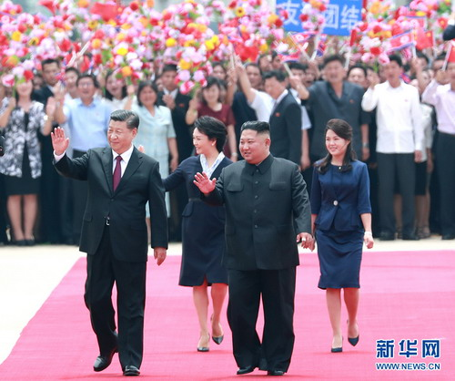

(Image: Xi Jinping, Kim Jong Un and their spouses during the Chinese leader’s June 2019 visit to Pyongyang, source: Xinhua)

Introduction

The existential North Korean nuclear and missile threats negatively impact the Asia-Pacific security environment for the United States, South Korea, Japan and Australia. In response, these countries have taken countermeasures to defend themselves against the growing danger from North Korea. As a result, North Korea’s nuclear and missile capabilities indirectly worsen China’s “security dilemma” by spurring the U.S. and its allies to devote greater resources to maintaining a strong security presence in Northeast Asia. This situation is illustrated by Beijing’s consistent criticism of Seoul for allowing the deployment of the U.S. Terminal High Altitude Area Defense (THAAD) anti-ballistic missile defense system in South Korea since 2017. Although South Korea has sought to reassure China that the system is aimed at counteracting the threat from North Korea, Beijing has maintained that the presence of the U.S. THAAD in Korea “clearly undermines China’s strategic security interests” (PRC Ministry Foreign Affairs [FMPRC], August 10, 2022).

Although China has been accused of not putting enough effort into the denuclearization process, achieving success in eliminating nuclear weapons from the Korean peninsula would serve China’s security interests in several ways, including by removing a powerful justification for the U.S. and China’s neighbors to devote resources to regional security. In part due to North Korea’s growing missile capabilities, South Korea, Japan and Australia have all recent strengthened their respective missile development programs. In 2021, the United States also lifted the restrictions it had imposed on South Korea limiting the range and payload of its ballistic missiles. According to previous South Korea president Moon Jae, this has removed “security shackles”—allowing South Korea to regain its missile autonomy (Korea Herald, May 22, 2021).

New Approaches in Japan, South Korea

In 2022, with new leadership under President Yoon Suk Yeol, Seoul has supported steps to expand and “normalize” THAAD operations in South Korea, making technical upgrades and allowing an additional eight acres of land to house the system (South China Morning Post, August 12, 2022). The PRC has criticized the move for contravening the “three noes,” which had become an operating principle for China-South Korea relations advanced by previous President Moon Jae-in: no further THAAD deployments; no joining U.S.-led missile defense networks; and no participation in a trilateral military alliance with the U.S. and Japan (Korea Herald, July 28, 2022). The Moon administration had previously used the Three Noes to reassure China, which helped stabilize relations in late 2017, following a diplomatic fracas triggered by China’s economic retaliation against South Korea following the initial deployment of the U.S. THAAD earlier that year to counter the threat from North Korea (China Brief, March 31, 2017).

Not only has South Korea changed its approach to security of late, but Japan has also moved to augment its military might. In November 2022, the ruling Liberal Democratic Party, along with its junior coalition partner, Komeito, reached a consensus that Japan should seek to acquire counter-strike capabilities in order to address the rapidly worsening regional security environment (Kyodo News, December 2, 2022). While China’s military modernization has played a key role in this deteriorating regional security environment, so too have North Korea’s nuclear development and activities. In fact, a real possibility exists that Tokyo will even purchase Raytheon-made Tomahawk cruise missiles (The Defense Post, November 30, 2022). Australia, too, has sought to focus on developing its cruise missile capabilities (Australian Defense Magazine, September 29, 2022).

Would China Change Course?

Recent developments concerning North Korea pose both traditional and non-traditional security challenges to China. While North Korea’s recalcitrance leaves China with neighbors strengthening their militaries, the continuing North Korean nuclear crisis presents other challenges as well. The most pressing issue is that as North Korea’s economy struggles under the weight of international sanctions, imposed for its nuclear and ballistic missile development activities, a growing number of people will seek to flee north to China in search of a better life. Again, dealing with a nuclear North Korea that has aggressive and unpredictable tendencies is a concern for China as its largest trading partner and main economic supporter.

Amidst these concerns, China could seek to play a more active and central role in promoting denuclearization of the Korean peninsula (Permanent Mission of the PRC to the UN, June 8, 2022). This is because, at this moment, only China and Russia are close enough to North Korea to have leverage with Pyongyang concerning the nuclear conundrum. The new leadership in South Korea is at loggerheads with Pyongyang, as opposed to the previous Moon government, which had a more cordial relationship with Kim Jong Un.

Hence, China has both the motivation and the ability to take a leading role in inspiring a change of course by North Korea. Also, China has an incentive to ensure that the sanctions on North Korea imposed by the United Nations Security Council (UNSC) are slowly lifted so that the North Korean economy does not implode further, which would have spillover effects on China (Xinhua, May 12, 2022).

China’s role in the North Korean nuclear crisis has become more prominent as Pyongyang has called off the self-imposed moratorium on testing nuclear weapons and long-range missiles it had observed since late 2017 and has resumed intercontinental ballistic missile (ICBM) tests (Yonhap News Agency, November 18, 2022). China’s role in the nuclear issue has also gained more prominence as doubts are cast on Beijing’s intentions to ensure a nuclear weapons-free North Korea that would result in a nuclear weapons-free zone (NWFZ) on the Korean peninsula. Some observers believe that North Korea will conduct a seventh nuclear weapons test this year, which would be its first since 2017 (CTBO, September 3, 2017).

For China, the first North Korean nuclear test in over half-a-decade could mean efforts by the U.S. to strengthen extended nuclear deterrence to protect its allies, Japan and South Korea (Huanqiu, November 22, 2022). In December 2022, Anthony Carullo, director of plans and policy at the U.S. Strategic Command, reaffirmed the U.S. commitment to South Korea regarding its extended deterrence that comprises both conventional and nuclear capabilities (VOV World, December 6, 2022).

U.S. National Security Adviser Jake Sullivan also reaffirmed this commitment stating that “[w]e are working within our alliances, with both the Republic of Korea and Japan, to develop an effective mix of tangible measures to this end and specific practical steps to take to strengthen the extended deterrence commitment” (The Korea Times, December 1, 2022). This implies a strengthened nuclear environment in China’s immediate neighborhood that Beijing would have to deal with.

These developments are not positive signs for Taiwan’s own security, especially as Taiwan faces territorial disputes both in East China and South China Seas. While the Senkaku/Diaoyu Island disputes remains an issue in the East China Sea, Taiwan claims sovereignty over all the islands in the South China Sea. In recent years, Taiwan has strengthened its military capabilities, including cruise missiles as well as holding live artillery drills. Hence, any military developments in the region will have a domino effect on Taiwan (India Today, August 9, 2022).

Conclusion

All these developments add to not just military pressures but also diplomatic pressures on China. Hence, China should play a more positive role in the North Korean denuclearization process by acting as a mediator.
Some of the steps that could be adopted are:

- Educate North Korean leader Kim Jong Un on the advantages of sanctions being removed.
- Make the case to North Korea on the technological advantages of being a Non-Proliferation Treaty (NPT) member.
- Persuade Pyongyang to return to its self-imposed moratorium on nuclear and missile testing; also convince South Korea not to engage in any military drills to provoke tensions. This two-way process can instill confidence in both Korean counterparts.

These measures could be discussed and analyzed by China, which could sketch out the impact these measures would have on North Korea and the Korean peninsula over the long run. The intersection of strategic competition between China and the U.S. and its allies and North Korea’s growing nuclear capabilities underscores that Pyongyang’s pursuit of its nuclear ambitions has security implications that reverberate not just on the Korean peninsula, but globally as well.

Debalina Ghoshal is a Non Resident Fellow with the Council on International Policy, Canada. She works on issues on nuclear, missiles, missile defense, artillery and space.

